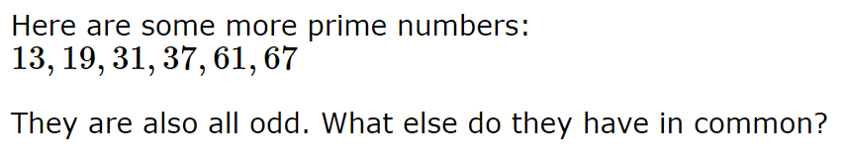
I’m answering the question above.

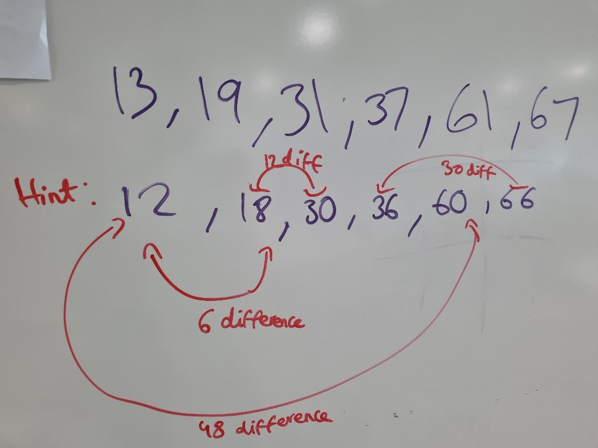
Here, the difference of any 2 numbers is a multiple of 6. In both the hint & the answer, it’s like that. 6, 12, 30 & 48 are all multiples of 6.
They all have a difference of a multiple of 6 when 2 numbers are subtracted with each other (bigger number subtracting a smaller number, not the other way around).

Wh

