We worked collaboratively on ‘More Less is More’ in a group of 12 students of 3rd and 4th grade, in online mode, in ‘Ganit Kreeda’, Vicharvatika, India. The names of the students are:
Eshaan, Rishaan, Samaira, Gowri, Vibha, Viha, Vansh, Vraj, Arya, Swarnim, Rudraraj and Renah.
We explored to solve all the 4 challenges mentioned here in that order.
Sum-sum
To maximize score, Rishaan used the highest digits 5,6,7,8 in the tens place. Now 50+60+70+80 = 260 and 260/2 = 130. 50+80 = 130 and 60 + 70 = 130.
So, 5_ + 8_ < 6_ + 7_
Swarnim and Eshaan said that they first fixed the ten’s place digit as 6,7 and 5,8. So that their addition is equal. Then they fixed remaining numbers such as their sum differs by 2. That means1+3 <2+4
Finally, we got 51+83 < 62+ 74 that means 134 < 136.
So, our highest score is 134.
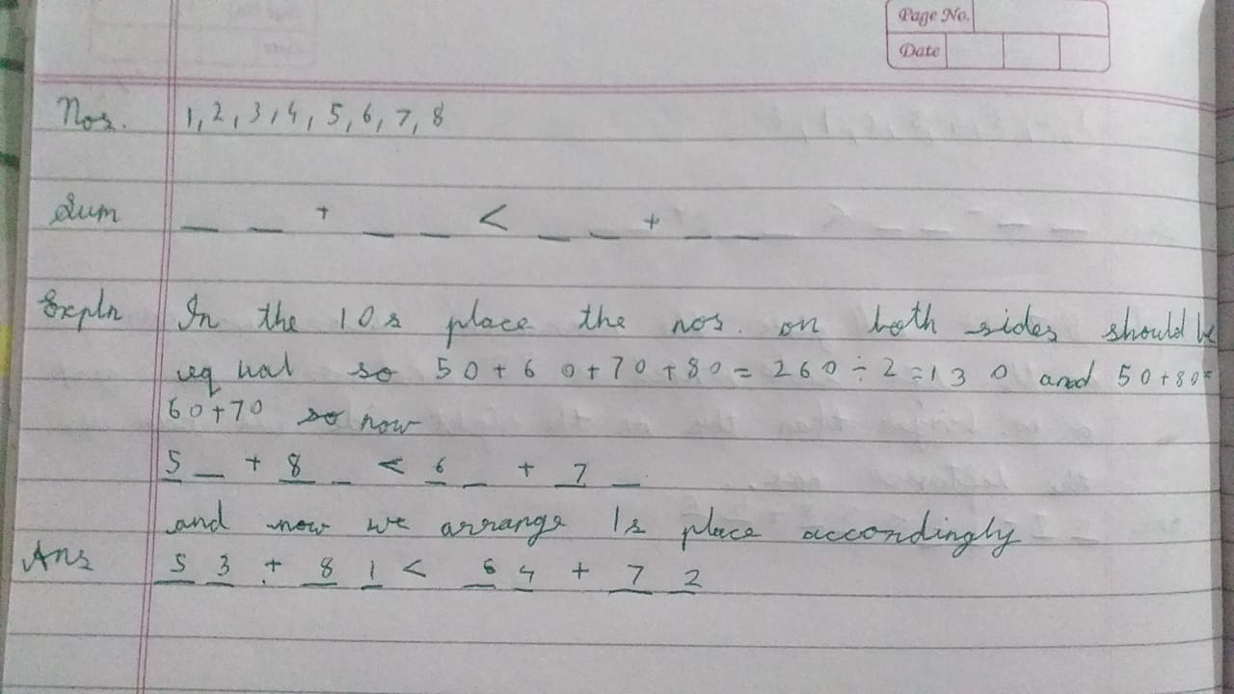
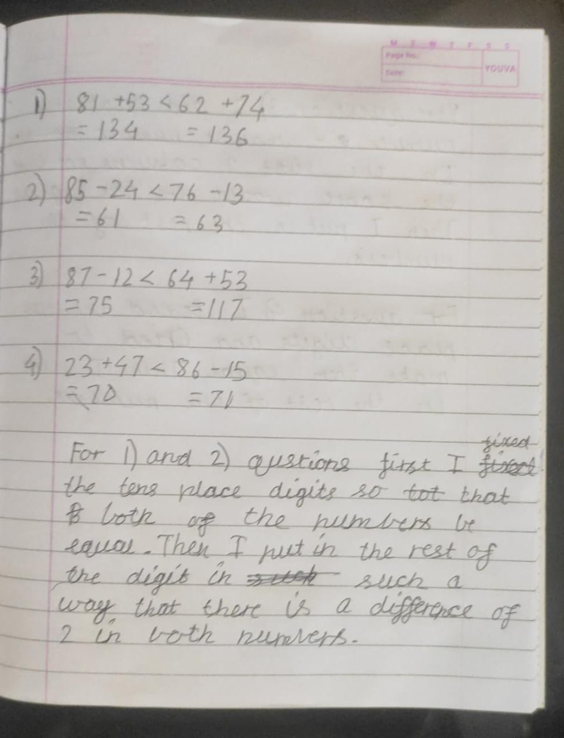
Take-Take
Swarnim, Vansh and Eshaan had used the strategy of
greatest number – smallest number to get the maximum difference.
Rishaan tried the numbers at tens place such as the difference will be maximum and equal for both the sides.
As 8-2=7-1 = 6
He used 8_ - 2_ < 7 _ - 1_
Kids then used the remaining digits at one’s place. Again, they used the same strategy as used in the first challenge. They tried to get the difference of 1.
85 – 24 < 76 – 13 or 61 < 63
The Highest Score is 61.

Take-Sum
87-12 which is 75 will give the maximum difference (on the left side) and that can be our maximum score. Now we can arrange remaining numbers in any order as the minimum sum we can make is 35 + 46 which is 81 and 81 is bigger than 75.
We can even write 87 – 12 < 64 + 53 (75 < 117)
So, we think this was the easiest challenge.
The Highest Score is 75.
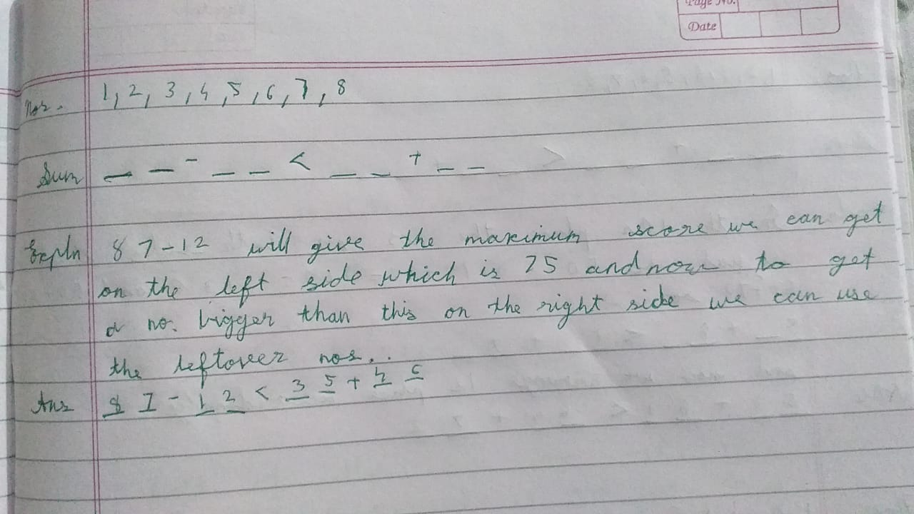

Sum-Take
First, we tried to use maximum difference which is 75 on the right side. But then using remaining digits
The smallest possible addition was 35 + 46 which is 81 and 81 >75. So, we tried to make right side 74 by changing 12 to 13 as 87-13.
With remaining digits we got
26 + 45 = 71 and 87 – 13 = 74 OR 46+25 < 87 - 13
The Highest Score is 71.
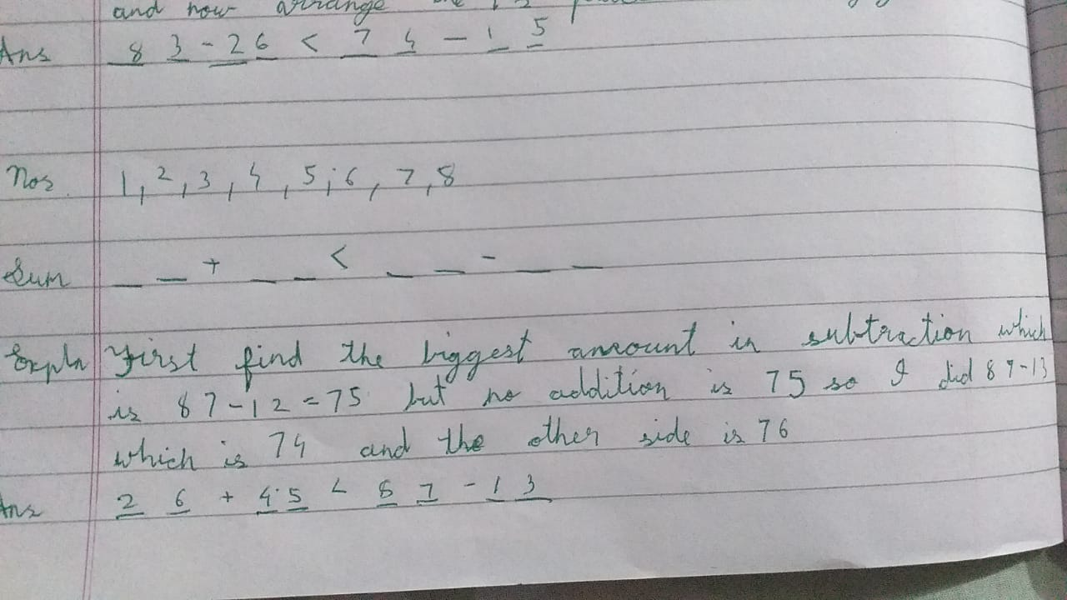
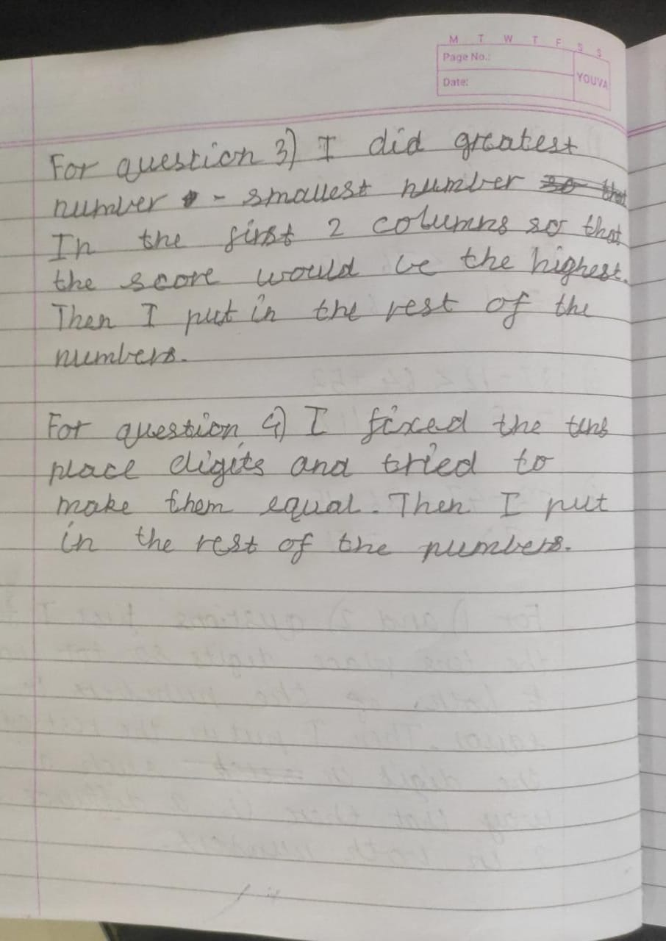
Gowri gave one general solution for any randomly selected 8 numbers.
