Seeing parallelograms

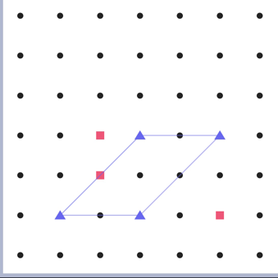
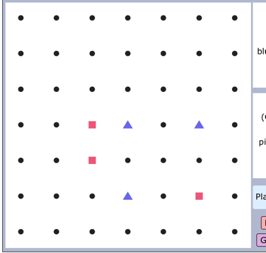
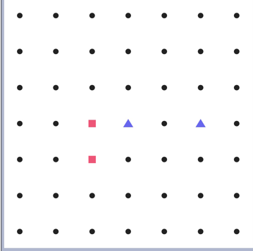
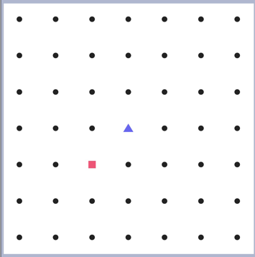
The computer always wins if it goes first because it starts making a shape and also give itself multiple options so you can’t defend it. If you go in the middle start by making small square like shown in the picture and whatever the don’t defend you put it down in the place. Then you win. Here is how you do it:

