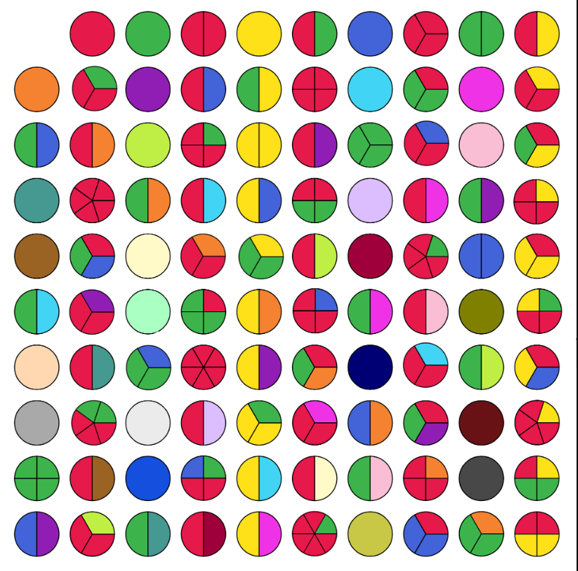

I noticed that the prime numbers were whole circles of just one colour e.g. 2, 3, 5 etc.
I wondered if the square numbers were all one colour but with exactly two sections e.g. 4 and 25, but then I noticed that 16 and 36 didn’t follow this rule, because both numbers are split into 4 sections and 36 has two different colours.
Looking at the top row, the different sections in each circle are factors of that number. E.g. 6 is made up of two sections of different colours which shows 2x3, and 10 has factors of 2 and 5.
Every colour and section represents a different prime factor of the number which is the whole circle.

Every single circle in the fifth column has a yellow factor, which is the number 5, as they’re all multiples of 5. All the circles in the far right-hand column have a red and yellow section, representing the factors 2 and 5.
Examples of numbers that have red and green factors are: 54, 48, 18, 12… All these numbers are multiples of 6, because 2x3=6. This is similar to the multiples of 10 (in the far right-hand column) containing red and yellow factors which represent 2 and 5. If it’s just red and green it’s only got prime factors of 2 and 3, but if the circle has another colour, then it has an additional prime factor that isn’t 2 or 3.

11 is a prime number, so multiples of eleven are each eleven more than the last. To add eleven on a hundred square like this you have to go down one and right one, which means you keep coming back to the same diagonal line which has a gradient of -1. Multiples of 9 are on a diagonal line that has a gradient of +1 and this is because to add 9 to a multiple of nine, means moving one circle down and one to the left.
8 is split into three parts the same colour because it is a cube number e.g. 2x2x2
Other cube numbers are: 27 = 3x3x3 and 64=4x4x4 (5x5x5=125 and this grid doesn’t go up that far)

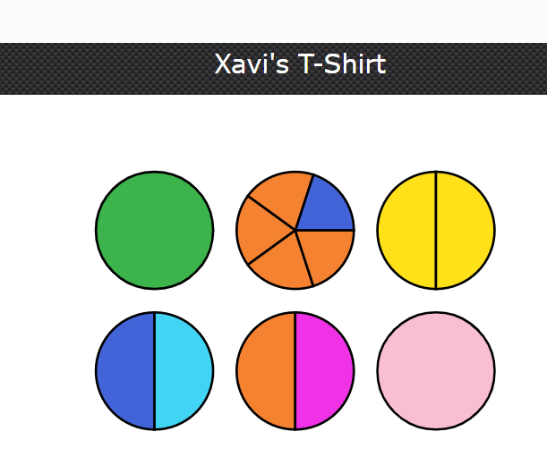
The yellow circle is a square number, because it’s got two identical factors.
The pink circle, which is a prime number (because it’s a single colour) has to be 10 more than the yellow circle. So prime numbers which are 10 more than a square number could be:
9 and 19
or
49 and 59

The green circle is also prime and has to be two less than the square number which is the yellow circle.
Two less than 9 is 7, which is prime.
Two less than 49 is 47, which is also prime. (So it still could be either pair from above.)

However. if the top line was 7, 8, 9 the middle circle should have just three sections all the same colour (2x2x2) and it doesn’t. So the top middle circle has to be 48 and the sections which are orange represent the factor 2 and dark blue represents the factor 3.
So the numbers are: 47, 48, 49, 57, 58, 59
And the factors are:
Green = 47
Orange = 2
Dark blue = 3
Yellow = 7
Light blue = 19
Bright pink = 29
Light pink = 59

