8:
Cubes of primes are in this style of 3 sections of the same colour.
Only 8,27 are this pattern as any larger prime has a cube above 100.

93,94,95:
Can’t find similar for 4 as two of them would have to be a multiple of 2 since there would be two even and two odds. Going in order OEOE or EOEO.

6 Sections:
Numbers with 6 prime factors.
Smallest is $2^{6}=64$
Then by replacing each factor by the next prime factor we can get all.
Replacing 1 of the 2s by 3 gives $2^{5}*3=96$
Replacing any more goes too big so 96 is the largest.
Therefore 2

5 Sections:
Numbers with 5 prime factors.
Smallest is $2^{5}=32$
Then by replacing each factor by the next prime factor we can get all.
32,48,72,80

4 Sections:
Same method as above, just takes a bit more time.
16,24,36,40,54,56,60,81,84,88,90,100

A few rounds of Scarf:
1)
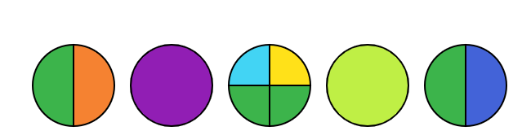
Green is 2
Yellow is 3 as no other colour repeats.
5 Must occur and can’t be the primes
1st is 5: 10,11,12,13,14 no as twelve doesn’t fit
3rd is 5: 58,59,60,61,62 works!

2)
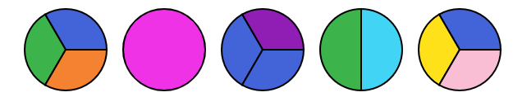
Blue is 2
Green is 3
5 Must occur and can’t be the prime
1st is 5: 30,31,32,33,34 no as 32 doesn’t fit
3rd is 5: 18,19,20,21,22 no as 18 doesn’t fit
4th is 5: 12,13,14,15,16 no as 14 doesn’t fit
Thus, yellow is 5.
1st is multiple of 6 ending in 6: 6,36,66,96
6 has 2 prime factors
36 has 4 prime factors
66 has 3 prime factors
96 has 4 prime factors
Thus, 66,67,68,69,70
3)
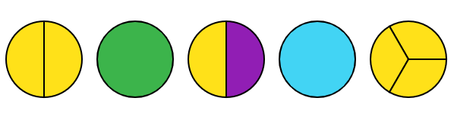
Yellow is 2
Thus: 4,5,6,7,8

4)
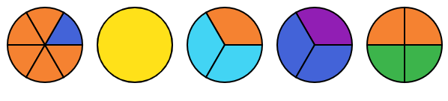
Orange is 2
Blue is 3
Thus: 96,97,89,99,100

5)
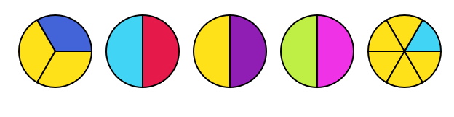
Yellow is 2
Cyan is 3
Thus: 92,93,94,95,96

