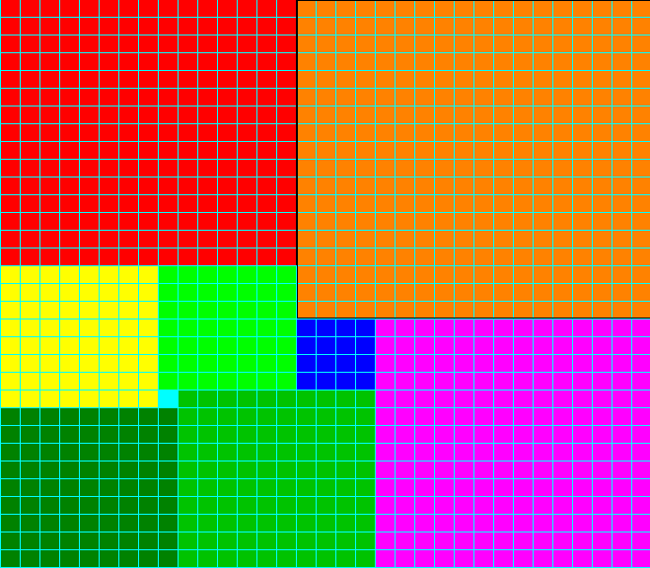
We decided to draw the shapes first in pencil, and then we cut them out. We then started to jiggle around with them which we found very hard and we weren’t getting anywhere. Then we looked at Chandra’s method on nrich which helped us, she had squared all the numbers to find out the area. So we squared the numbers then add them all up and it equaled 1056cm², then we divided it by 2 which equal 528 cm², then we carried on dividing it by 2 until it didn’t work that number was 33.Then we divided 1056 cm² by 33cm, which equaled 32cm so we figured out that, which was the dimensions. Once we found that out it made it so much easier to do the rectangle. To get the rectangle we had to add the rows up which should add up to 33cm or 32cm which was very easy.

By Thomas and Ollie Year 5

