Our Solution

At the beginning we put the smaller squares into the largest square (18) we drew all of this on white boards. Soon after we had started we decided that this was not going to work as the squares would not fit in equally.
Then we drew all of the different squares onto a piece of paper, we kept trying and eventually decided that this method would take a long time.
After we had tried that we cut out all the different sized squares to fit them together, we tried different ways of putting them together like we lined all the shapes up from smallest to largest and we put the smallest with the largest and then the smallest with the largest and so on. We found out that we could not leave long gaps as no shape would fit. We started putting the squares together and we came to a solution by finding which shapes would fit nicely together.
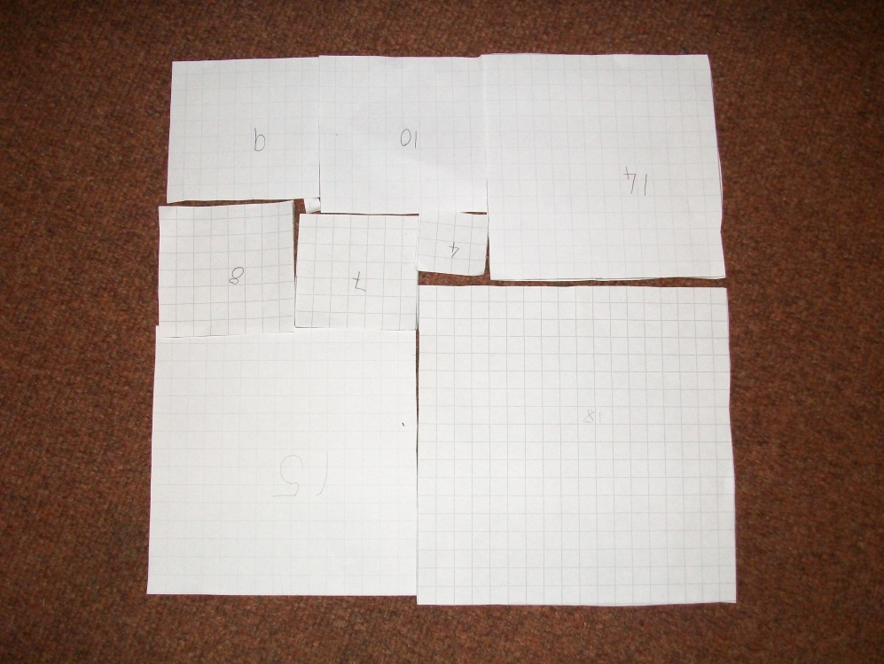
By Olivia Moran and Isabel Macnutt

