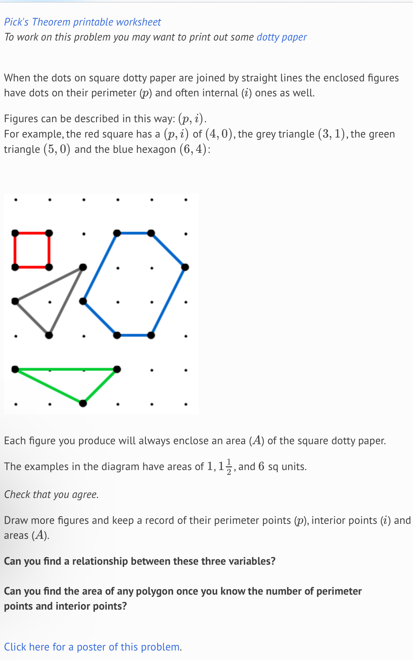
- I will use the App ‘Apple Freeform’ (screenshot) to illustrate the shapes on the dots paper to show the idea more clearly and accurately.
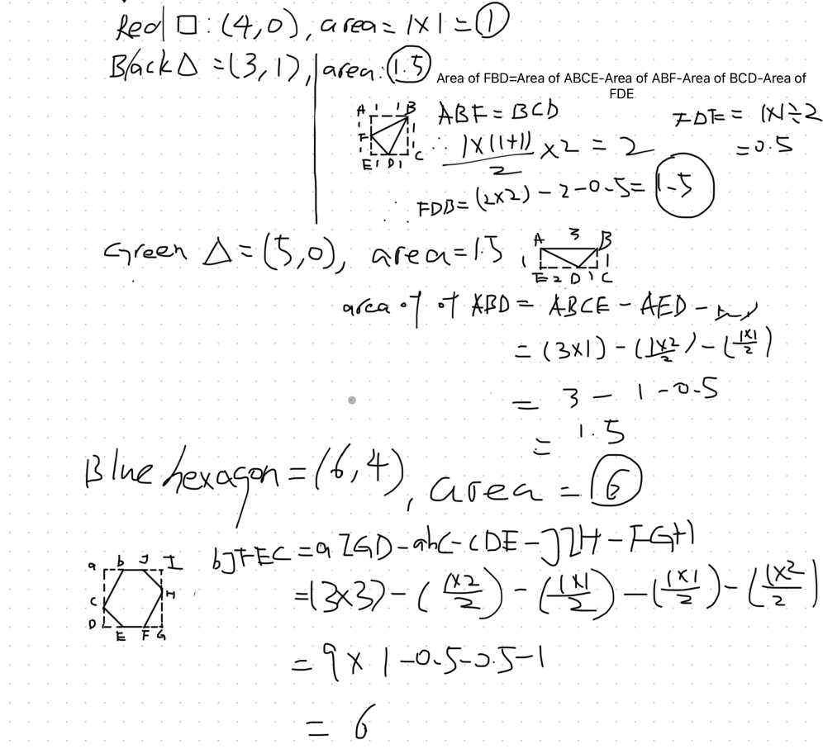
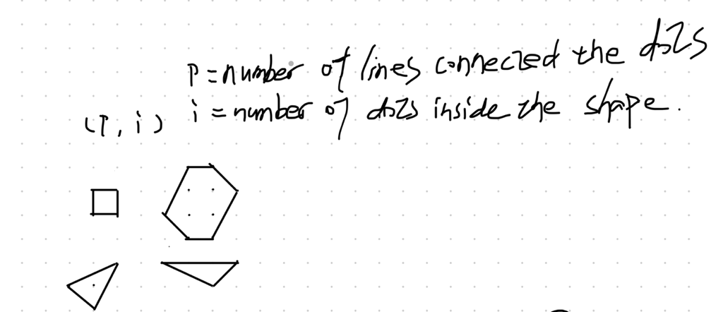
Annotation:
- Firstly, I want to understand the relationship of ‘p’ and ‘i’.
- Therefore, I need to work out the area of the shapes and the value for (p,i).

