Created by: Daniel Kim, Tony Wang, Bryan Fang, Aidan Moore, and Will Chen

The question tells us to find Pick’s Theorem through how the shapes they gave us are related. The question states how many dots on the perimeter of the shape is P, and how many ones are inside it. So, for the square (A) it is (4, 0). The grey triangle (B) is (3, 1) etc.
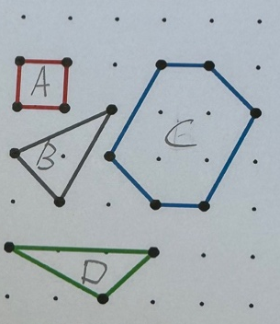
Here is a list on the P and I and their area to find relations between them. (We are saying that the between each dot is 1.):
 | P | I | Area
A (Square) | 4 | 0 | 1
B (Grey Triangle) | 3 | 1 | 1.5
C (Hexagon) | 6 | 4 | 6
D (Green Triangle) | 5 | 0 | 1.5
From the data above, we had assumed that the Pick’s Theorem is an equation, in form of “$A=aP+bI+c$”, there, we got the following equations:
Equation 1: $4a+c=1$(shape A)
Equation 2: $5a+c=1.5$(shape D)
Subtracting equation 1 from 2, we get:
a = 0.5
Substituting the data from shape D into equation 2, we got $a=0.5$, $c=-1,$now with a and c, we can easily work out that $b=1$.
With this we can work out that the equation
Which is A=ap+bi+c=0.5p+i-1=p/2+i-1
Proof:
Now, after we had done trying to work out the theorem, we should start to proof the equation:


