We had an idea that each shape has a set of formulas that determine the variables. We started off with squares and soon discovered multiple rules:
S1 (Sequence 1)
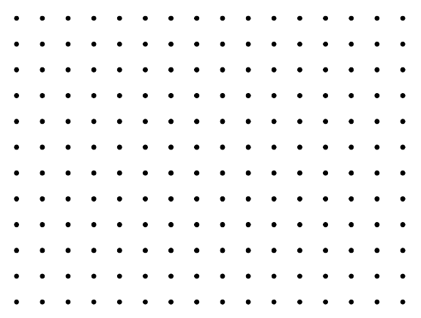
S2
S3
(Just remember, the side is always the amount of dots, not lines).
The sequence is the pattern of squares. For example, a 1 x 1 square would be S1, a 2 x 2 square would be S2, and so on.

Area (a)= (height - 1)²

Perimeter (p)= $\sqrt{a}$ x 4

Interior (i)= (S [Sequence] – 1)²

We named this sequence the “Golden rule”, and tried to do the same for other shapes, such as triangles, however found there was a different “Golden rule” for each shape:
S1 (Sequence 1)

S3
S2

Area = Height² $÷$ 2

(We know that the perimeter is ¾ of the corresponding square)
Example: The S3 square has a perimeter of 12, and the perimeter of the S3 triangle is 9.

Perimeter = perimeter of (the corresponding square of that triangle) * ¾

Interior = (S-3) + (tr [p]) + (tr [i]) (obtain the sequence three less your triangle and add it’s perimeter and interior).

Tr = Triangle
P = Perimeter
I = Interior

Rectangles:

Area = (L-1) x (W -1) L: Length (counting the dots)
Perimeter = (W x 2) + ([L – 2] x 2) W: Width (counting the dots)
Interior = (L – 2) x (W – 2)
Octagon:

Area = ([Os – 1] x 3)² – ([Os – 1] $×$ 2) Os: 1 octagon side
Perimeter = ([Os – 1] x 8)
Interior = Interior of ([Os – 1] x 3)² – Interior of ([Os – 1] x 2)

