Triangular numbers
Arrange the numbers 1 to 6 in each set of circles below you can only use each number once.
The sum of each side of the triangle should equal the number in the centre of the triangular shape.

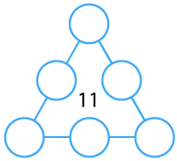
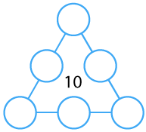
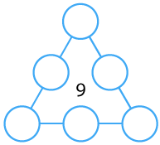
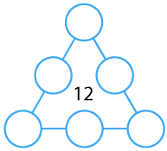
5
4
1
5
2
3
6
1
5
3
4
2
6
6
3
2
5
4
1
4
3
1
2
6

