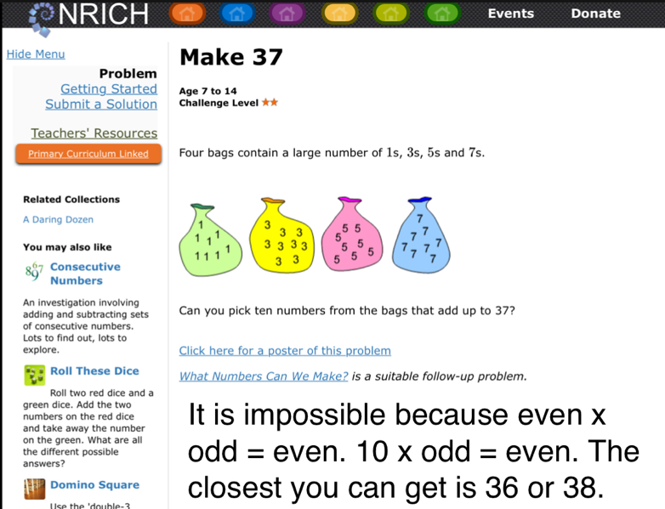
In our solution to this problem, we started by writing out all of the numbers and gradually crossing them off after every time we used.
The closest that we got was 36 (ten numbers) 38 (ten numbers) and 37 (nine numbers). After a long while we started questioning even and odd multiplication and addition.
Fortunately for us, we remembered that even multiplied by odd = even.
As soon as we had remembered that we found out that it was impossible to get 37 because 10 x odd = even.

