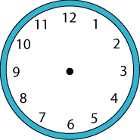

First I added up all of the numbers- 78 was my total.
Then I divided that by two.
Then I tried to find a way by taking a guess, then working out how far away I was from my goal.
Eventually I got this answer.

