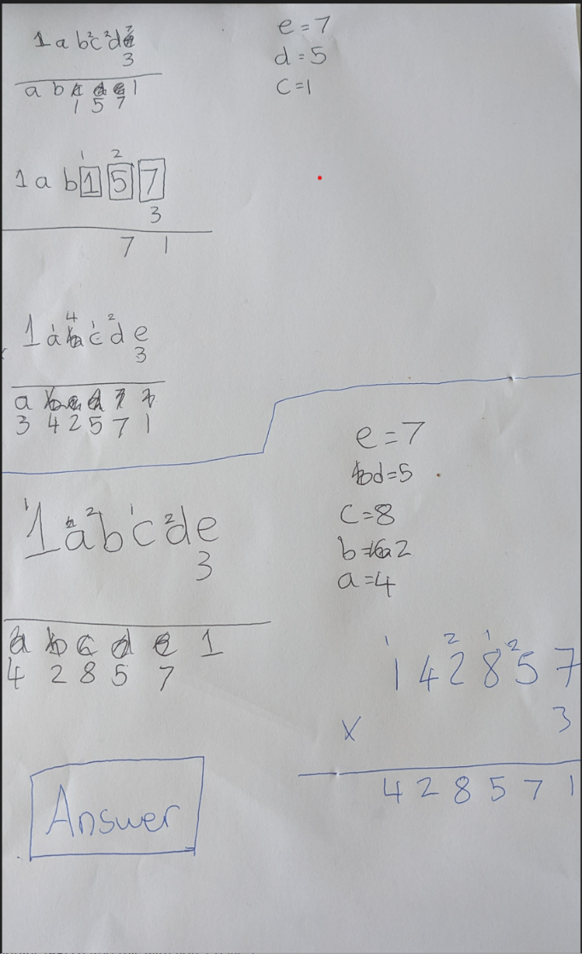
Top Tip
It helps to add a key as then you don’t forget what the letters are as numbers!
First problem:
To solve this problem I started with the first column which had an e in it. I knew that we were multiplying by 3 so I asked myself ‘what multiplied by 3 gets you a number that ends with a 1’ I came to the conclusion that e could be 7 as 7x3 gives us 21 which ends with a 1. Now after this I moved onto the next column. In the next column I knew that there would be a carry of 2 from the first column. So, I then asked myself what 3 multiplied by something add 2 would be. However, I noticed in the answer box there is an e which in the last column I thought would be 7 so this means that the number in the second column would end in a 7. Then I thought about what the closest number in the 3 times table to a number that ends in a 7. I concluded that d = 5 as [3x5] +2 would get you 17 which is a number that ends in 7. Then I moved onto the 3rd column. There was a d in the answer column which means that the 3rd column answer is going to end in a 5 as d=5. We also have a remainder from the 17. So I had to ask myself ‘what multiplied by 3 add 1 gets me an answer that ends with a 5’. I instantly thought of 25 seeing as c could be an 8. First, I tested out if c could be 8 by multiplying 3x8 and then adding 1 which gives me 25 which is a number that ends with a 5 so that would work. After this I continued this method until I solved the problem.

