Nrich – Trebling Solution
By Mary, Gioia and Maia

Here’s the problem we were given to work on:

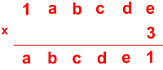
First we wrote out all the 3x tables up to 9, because you are multiplying by 3, and it had to be x9 or below. 0x3 1x3 2x3 etc…

Then we found out e,
The key to this problem, is to work backwards.
To find e, we had to think: what is a multiple 3 (Below 3 x 9) that ends in 1 For this we looked at our list of multiples of 3, and saw that only
7 x 3 = 21
So e = 7. There’s the first bit done, all you need to do repeat the same process. Here’s how we set out our work, which led us to the answer, easily, and quickly.
A =
B=
C=
D=
E=

