Tilly, Anna and Emily’s solution to Trebling- Nrich Problem

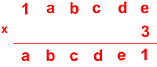
We wrote down the three times tables up to 9x3 to help us. Then we had to work out what 3xe was which had to end in 1. This meant that the answer had to be 21. Then we had to work out 21 divided by 3 which equals 7. Then we knew that e=7. This is where it got confusing! We had to carry the 2 from 21 to above the d on the top. Then we had to subtract 2 from 7 to find out what 3xd was. 3xd had to be a 2-digit number ending in 5. This had to be 15 which meant d=5 because 5x3=15. Then we continued this method throughout the problem using the tables which are pictured below:
 | 1 | 4 | 2 | 8 | 5 | 7
x |  |  |  |  |  | 3
 | 4 | 2 | 8 | 5 | 7 | 1

a=4 b=2 c=8 d=5 e=7
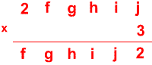
We also used this same method to solve the next problem, starting with having to work out what jx3 was and it had to end in 2. This had to be 12. We knew that 12 divided by 3 was 4. So j was 4. Then we used the previous method to finish:
 | 2 | 8 | 5 | 7 | 1 | 4
x |  |  |  |  |  | 3
 | 8 | 5 | 7 | 1 | 4 | 2

f=8 g=5 h=7 i=1 j=4
This is our trebling solution…

