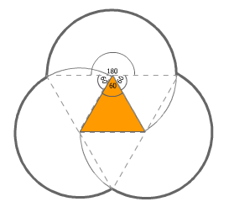
Perimeter of Triangular Base Flower
The circumference of each circle is 2πr. This is halved because the circles overlap, with the angle of each exposed part being 180°. There are three circles. Therefore the perimeter is
$$P=3×\frac{180}{360}×2πr=3πr$$

Perimeter of Square Base Flower
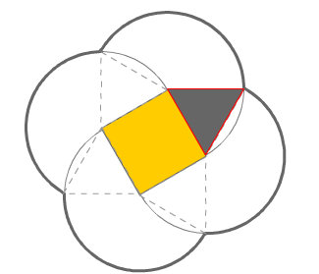
The circumference of each circle is divided by the angle of the exposed section over 360°. The angle of the exposed section is worked out by adding the internal angle of the polygon base (here 90°) to 2 x the internal angle of the triangle (2 x 60°). This circumference must then be multiplied by the number of petals, which is the same as the number of sides of the polygon base:
$$P=4×\frac{360-(90+2×60)}{360}×2πr=\frac{1200}{360}πr=31/3πr$$

Perimeter of Pentagonal Base Flower
$$P=5×\frac{360-(108+2×60)}{360}×2πr=\frac{1320}{360}πr=32/3πr$$

Perimeter of Hexagonal Base Flower
$$P=6×\frac{360-(120+2×60)}{360}×2πr=\frac{1200}{360}πr=4πr$$

For every additional side added to the polygon base, $1/3πr$ is added to the perimeter of the petals.
This is an arithmetic sequence:
$$a_{n}=a_{1}+\left(n-1\right)d$$

$$d=1/3πr$$
$$a_{1}=3πr$$
$$n=\left(number of sides of polygon\right)- 2$$

$$a_{n}=3πr+\left(n-1\right)1/3πr$$

Perimeter of 100 sided polygon base flower = a₉₈
$a_{98}=3πr+\left(98-1\right)1/3πr=\left(3+\frac{97}{3}\right)πr=351/3πr$

Perimeter of 100 sided polygon base flower = 35¹/₃πr

