Triangles and Petals- A Geometric Problem
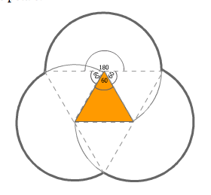
Solution written by Lucie M. and Hannah F.

On this diagram, we can see that the ‘petals’ are made of half-circles traced by an equilateral triangle. Therefore, each circle has a diameter which is twice one length of the equilateral triangle.

The circumference of a circle is calculated as:
Circumference=dπ where d= diameter.

The variable T represents one side length of the equilateral triangle.

To calculate the circumference of the ‘petals’, you would need to find the circumference of 1 circle, divide it by 2 to get the circumference of the petal, and multiply by three as you have 3 petals.
Therefore:
The perimeter of the petals can be calculated as:

This can be simplified to 3tπ, which is the circumference of the petals.

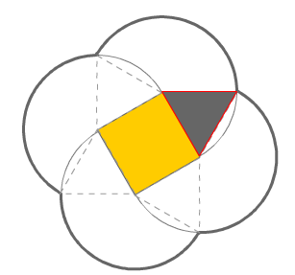

This math can be applied to solve the four-petal flower as well, however here the diameter is a slightly more complicated.
A circle is a complete revolution of 360°. The circumference of a certain portion can be calculated if you know the interior angle of that portion. This is what we will do.
In the diagram above, you can see that the perimeter of the petals has an interior angle of 150°.
We added 90° (one angle of the square), to 60° and 60° (one angle of each of the two triangles). This equals 210°. However, this is the sum of the degrees ‘left over’ outside the portion of the circle we are interested in. Thus, to solve for our relevant value, we subtract 210° from 150°.

The length of the triangle, therefore the radius, is the same, so you can still work with T.

We solved for the ratio , by adding the angles coming from the core of the circle, meaning we added 60° with 60° and 90°, which equals 210°. Therefore if you subtract that from 360°, the result is 150°. We simplified the ratio, to . We used the angles of the two triangles and the square.
So you can calculate the circumference, and the result is 3Tπ

Pentagons, Hexagons, Heptagons and other monsters:

Now we could use our method of using the angles at the center of the ‘petal’ to solve for how much of the circle is used, to solve for the pentagon and even a hexagon.

The internal angles of a regular pentagon are 108°. Therefore, we add 60°, 60° and 108°, which equals 228°. Subtracting this from 360° gives us 132 °. Thus the ration is , which can be simplified to .
Therefore, by inserting this ratio into the formula we receive

This can be simplified to
Then to .

Following the same steps with a hexagon:
The internal angle of a hexagon is 120°. Add that to 60° and 60°, and you will get 240°, thus giving the ratio , which can be simplified to .
Insert this into the formula:

Simplify this to

And finally:

Now a heptagon:

The interior angles of a heptagon are 128.57°. Add that to two 60° angles, which equals 248.57°. Subtract that from 360° equals 111.43. .
This ratio can then be plugged into our formula: .
Simplify that to .
Then to .
And finally to: which is roughly

The perimeter increases by about each time a side is added to the central shape. Compare 3Tπ, , and .

We apologize for the big blank space here, which is here only due to formatting problems that are too finicky to solve, and hope this happy smiley face will make you feel better. It surely will make everyone happy! Thank you for your understanding and for reading through our wonderful, enlightening solution.

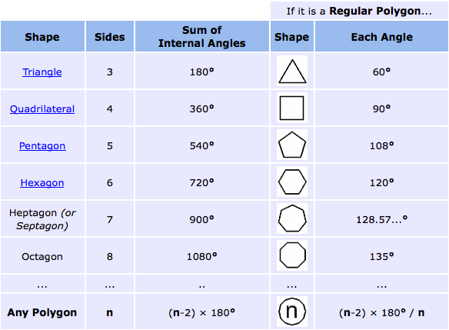

Solving for a 100-sided polygon:

For a 100-sided polygon, we can substitute 100 for n.
(100-2) x 180= 17640. This is the sum of the internal angles.
Then, solve for the value of each internal angle:
(100-2) x 180/100.
= 17640/100 = 176.4 °. This is the internal angle of a polygon with 100 sides.
360-176.4 = 183.6 gives us the ratio:
, which can then be simplified to: .

Inserting that into our formula gives us: .
This simplifies to .
And finally finishing with: .

Our method:
- Ascertain the interior angle of the central shape (for an equilateral triangle it is 60°, a square 90°, a pentagon 108°, a hexagon 120°, etc)
- Add the interior angle of the central polygon to 60° and 60°, as there are 2 triangles on each side of the corner of the polygon. Subtract this from 360°.
- Using the sum find out the ratio (=sum/360°)
- Simplify when possible.
- Plug into this formula, where s= number of sides of the central polygon, and is the ratio of the interior degrees of the circle over 360°. (We put this as as some ratios can be simplified, so y will not always be 360°.)
- Simplify where possible. can sometimes be simplified, y and s sometimes cancel out.

N.B: T is equal to the side length of the equilateral triangle, and also the radius of the circles.

"Interior Angles of Polygons." Math is Fun - Maths Resources. N.p., n.d. Web. 20 Sept. 2010. http://www.mathsisfun.com/geometry/interior-angles-polygons.html

