Fractional triangles- from the Maths Challenge group, St. Aidan’s VC School, London N4

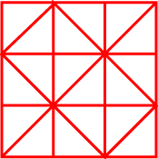

We all compared our answers and came up with these as our final results. We looked very carefully at 5 and 7, 3 and 6 in order to be sure that they were different answers not merely a rotation. We are happy with our results after our discussion.

