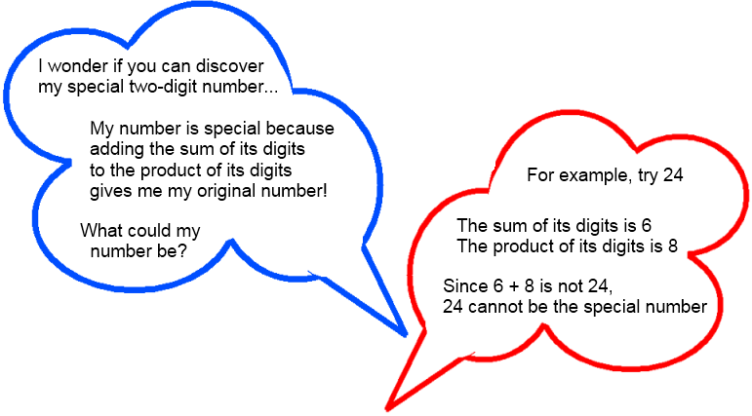
Let the special number be xy- it is xy because it is made up of 2 digits.
Add the sum of xy’s digits to the product of xy’s digits = xy + (x+y)
So… xy+x+y=10x+y
Since the adding the sum and the product of xy gives me the original number, which is one tens (10x) and one unit(y) xy+x+y=10x+y
Solving the equation
Xy+y-y=10x-x
Xy=9x
Y=9
So as y was the unit number, the unit number is 9 and as long as the unit number is 9, no matter what the tens number is, it will always be your special number!

