Number Pyramid
By:Lily, Kristin, Jihyo, Julie

Solutions:
1)If I tell you the numbers on the bottom layer, can you work out the top number without working out the middle layer?
Yes.
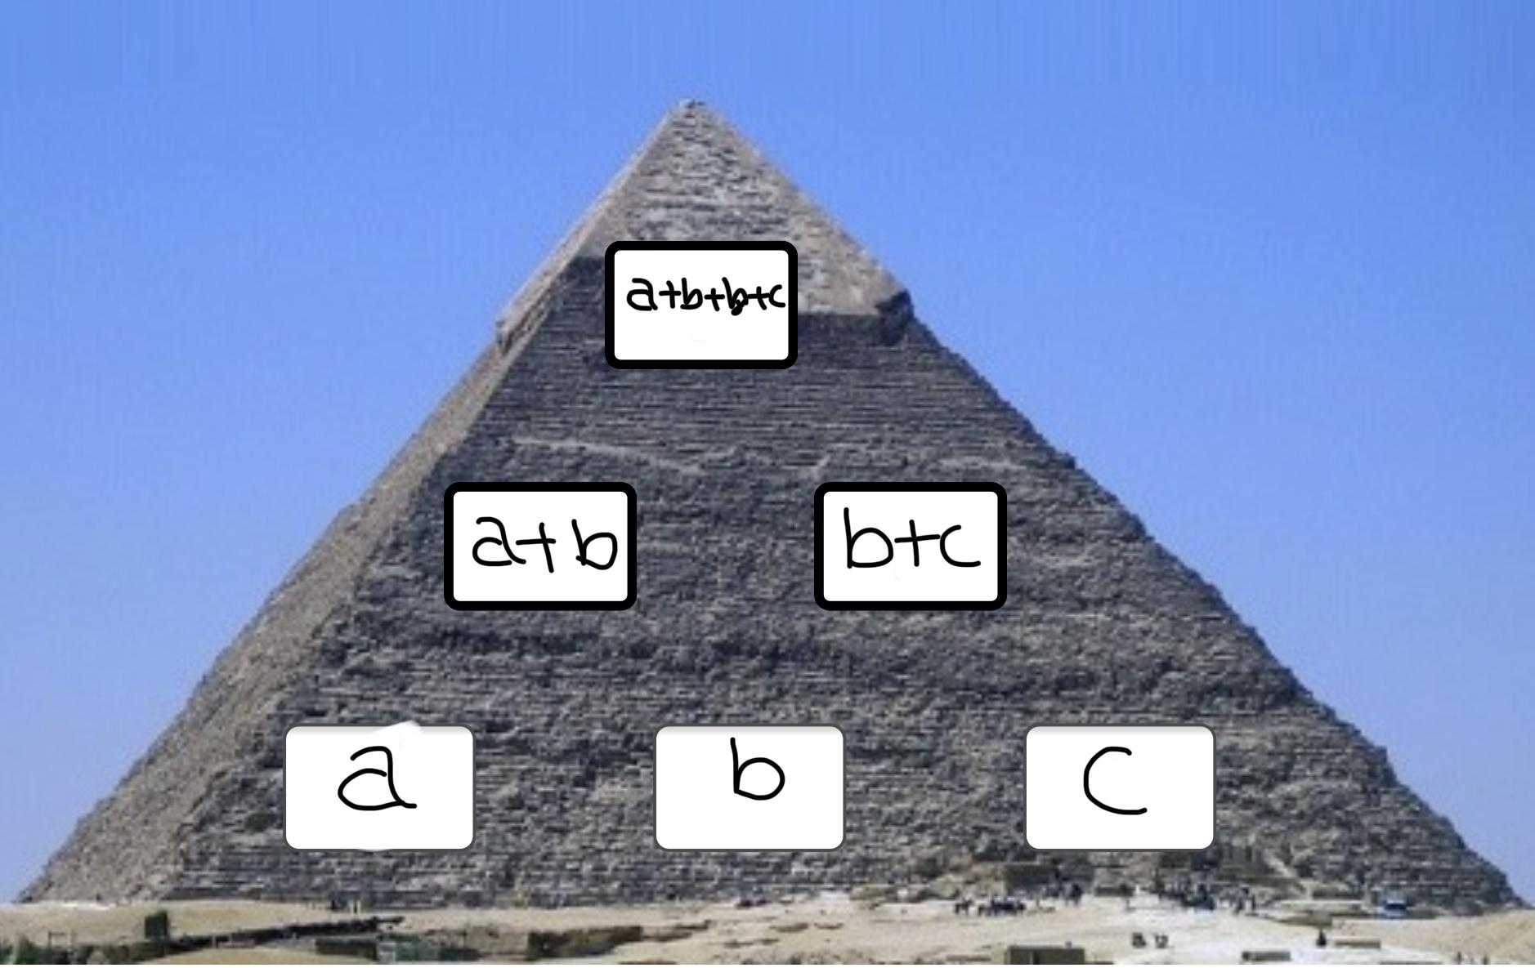1. We realized that when there are 3 numbers the formula is a+b+b+c which is the same as adding the bottom 3 numbers and the middle value.We found this out by replacing the numbers with letters.Another way we found this was observing the numbers carefully and thinking about formulas that would make sense in this question.One of the reasons we found was since we are assuming b is the middle value it would be added on twice. O
nce with a the smallest value and another time with c the largest value.Finally,after testing it with reasons and evidence in this formula we figured out that this formula actually worked.

2)If you change the order of the numbers on the
bottom layer, will the top number change?
Yes, it will change. We saw this here:
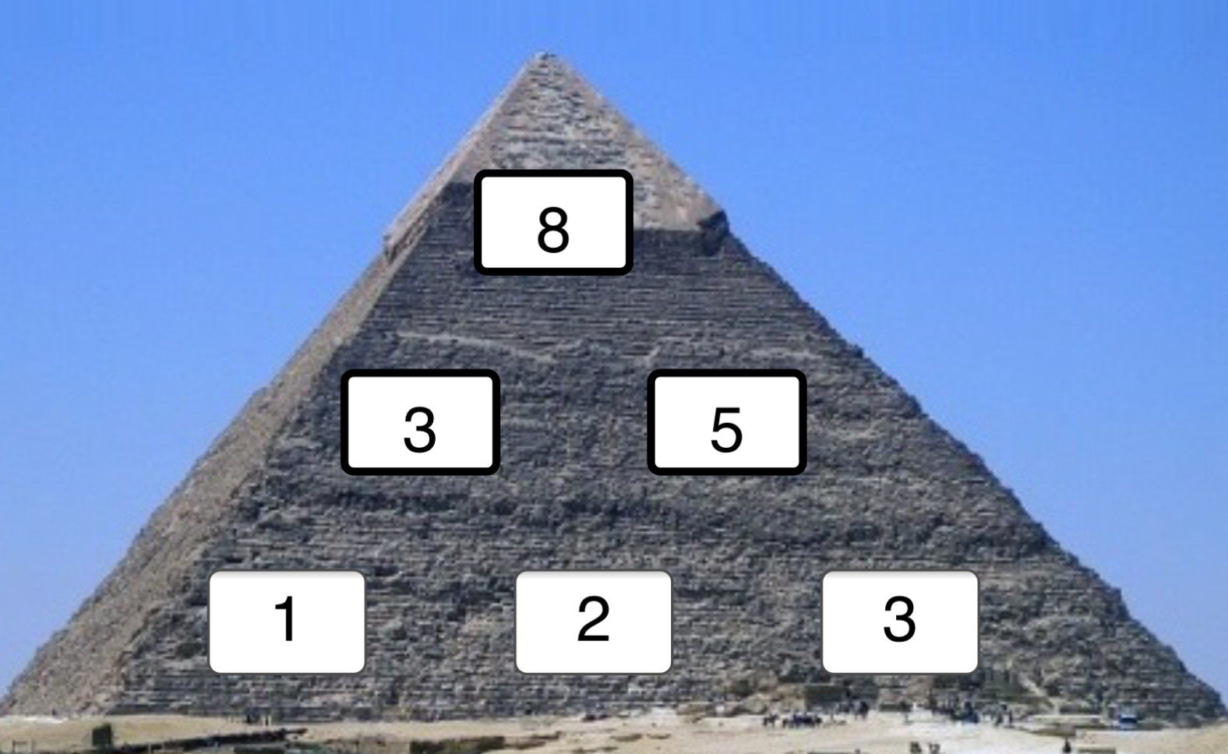

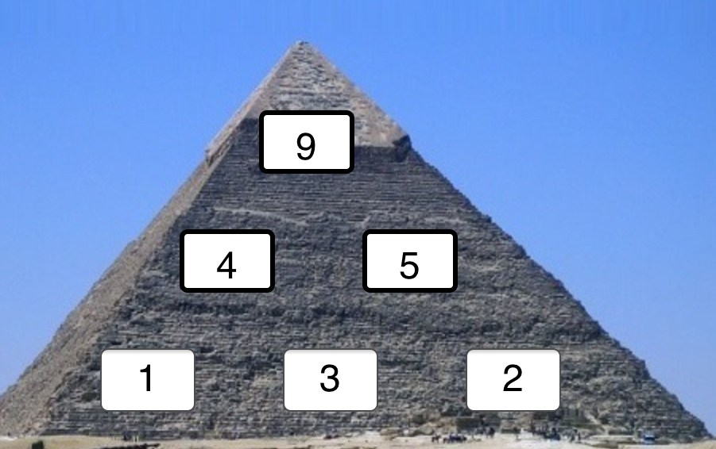
This happens because as explained in question 1 the formula is a+b+b+c. So in the first photo ‘2’ is being added twice and in the second photo 3 is being added twice instead of two. So if the bottom number is 3,1,2 in order then 1 is being added twice. Then the top number will be 7. This question is also a no because if you change the sides then the number in the middle doesn’t change.

3)Given any three numbers for the bottom, how can you work out the largest possible number that could go at the top?

If assuming a,b,and c are places in the pyramid in that order from left to right or vice versa you can work it out because if the numbers are a,b and c, you need to add the middle number once to the smallest number (a) and once the number (c).
Therefore,if you want the largest possible number the number that is being added twice (b) should be the largest because despite the two edge numbers changing sides it won’t make any difference to the value of the top number as mentioned in question 2.

