3 storey pyramid
Formula for getting the top number: Add all the numbers from the bottom layer and add the middle number(not the middle value).
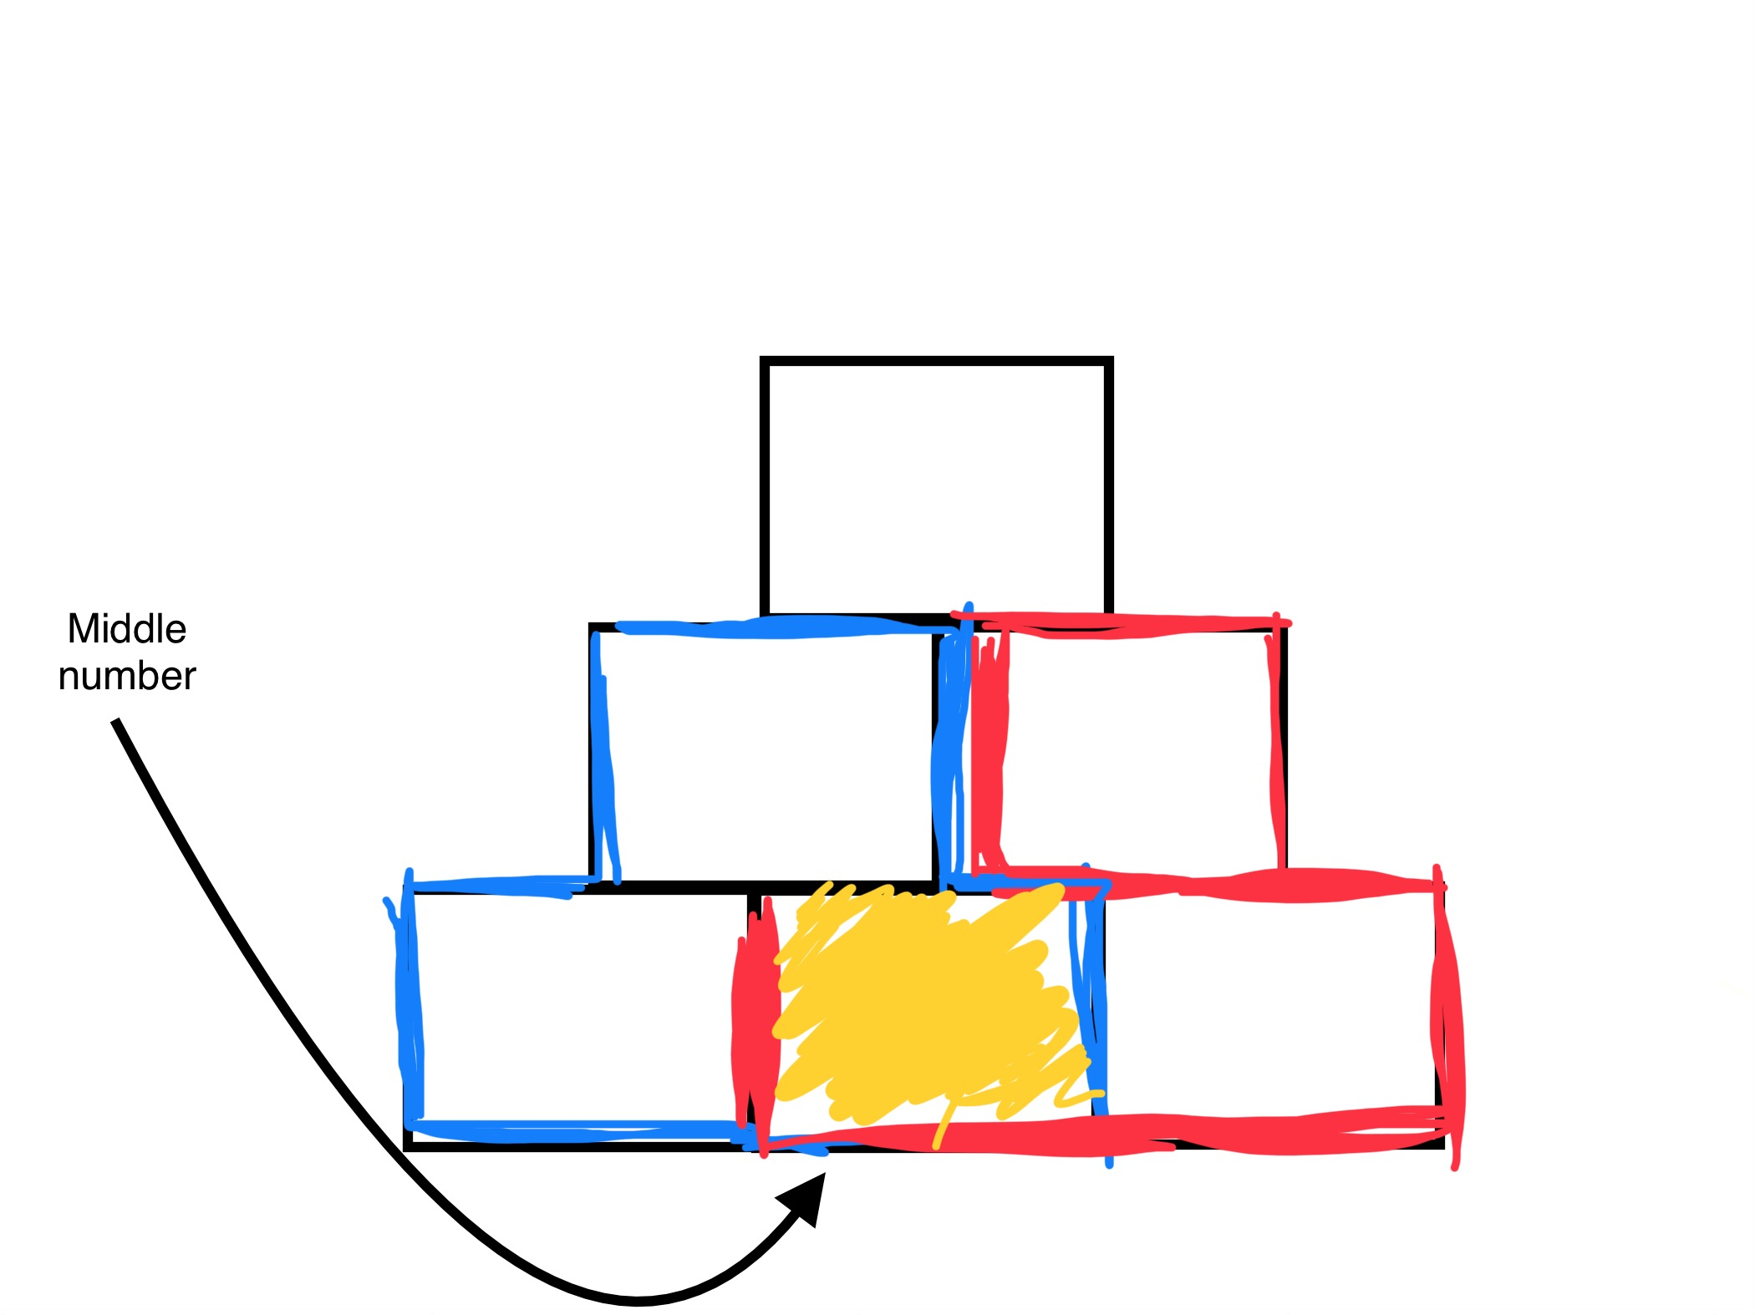
Explanation: The middle number is added 2 times because of the two 2 layer pyramid. Example A = B+C = D+E+E+F

We can extend this to bigger pyramids like a 4-storey pyramid.

Formula for getting the top number: Add all the bottom layers together, and then times the answer by two.
Explanation:you can use information from 3 layer pyramid. There are two 3 layer pyramids in the 4 layer pyramid. A = B + C
B = G + H + H + I
C = H + I + I + J A = B + C = G + H + H + I + H + I + I + J
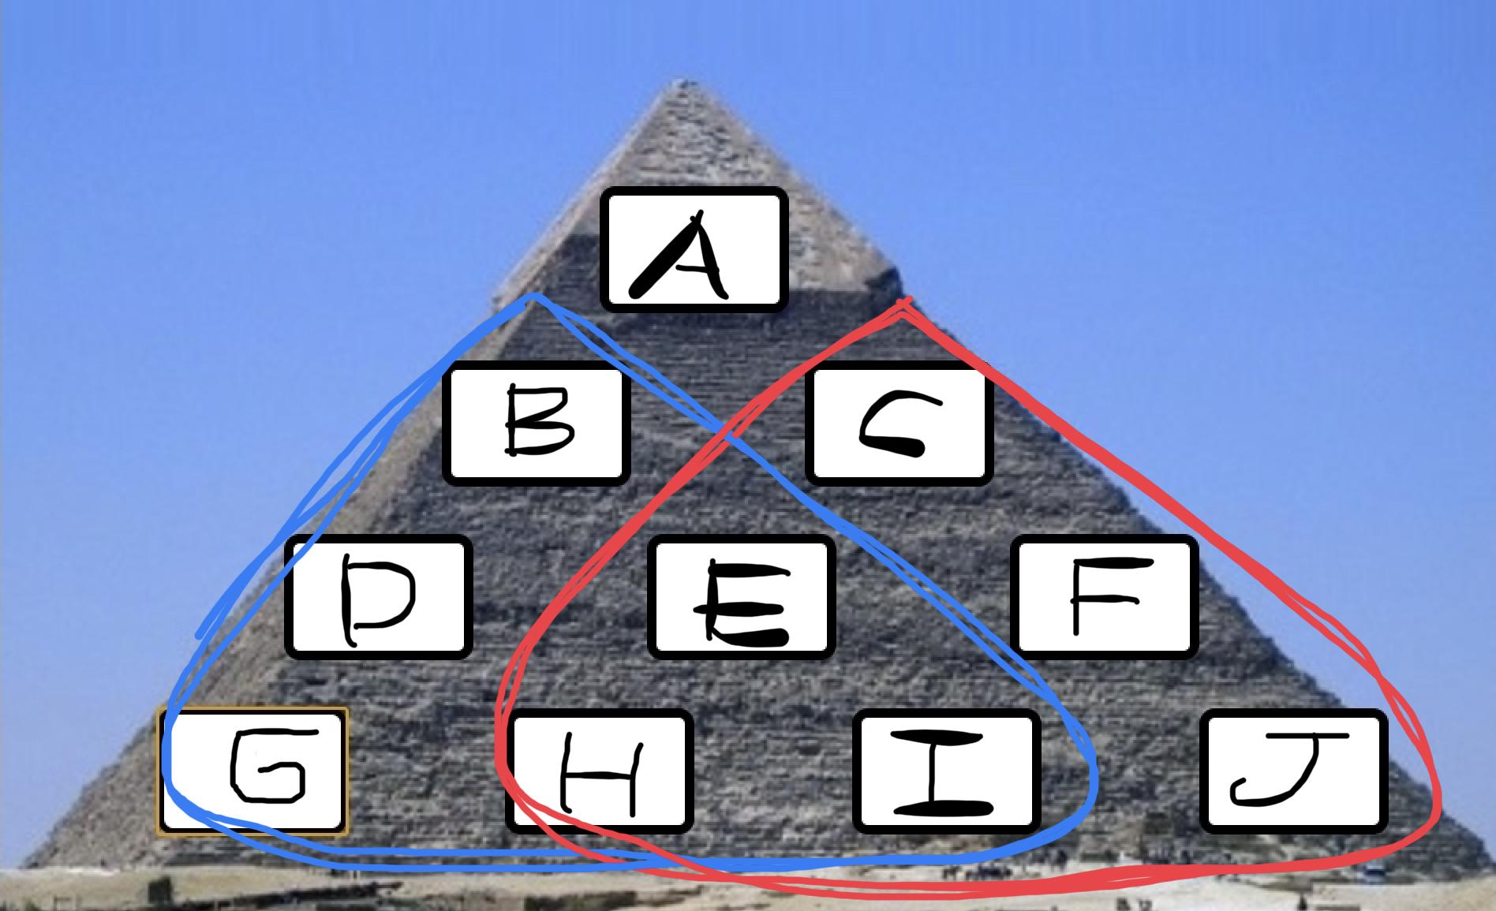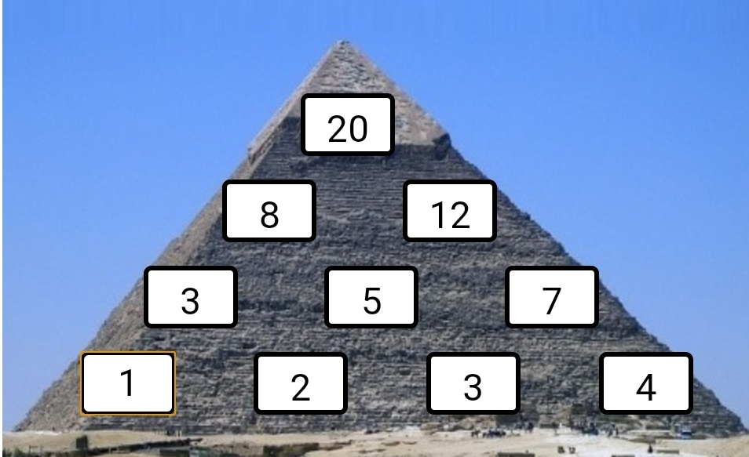
Example : The bottom numbers of this pyramid are 1,2,3 and 4. If you add all of them, it is 1+2+3+4=10. Now, you have to times the number by two : 10×2=20.
The top number of this pyramid is also 20, which means the formula is correct.
This formula works even if the bottom numbers change.

