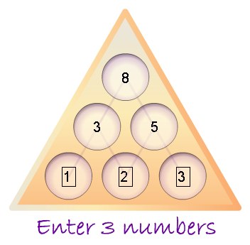
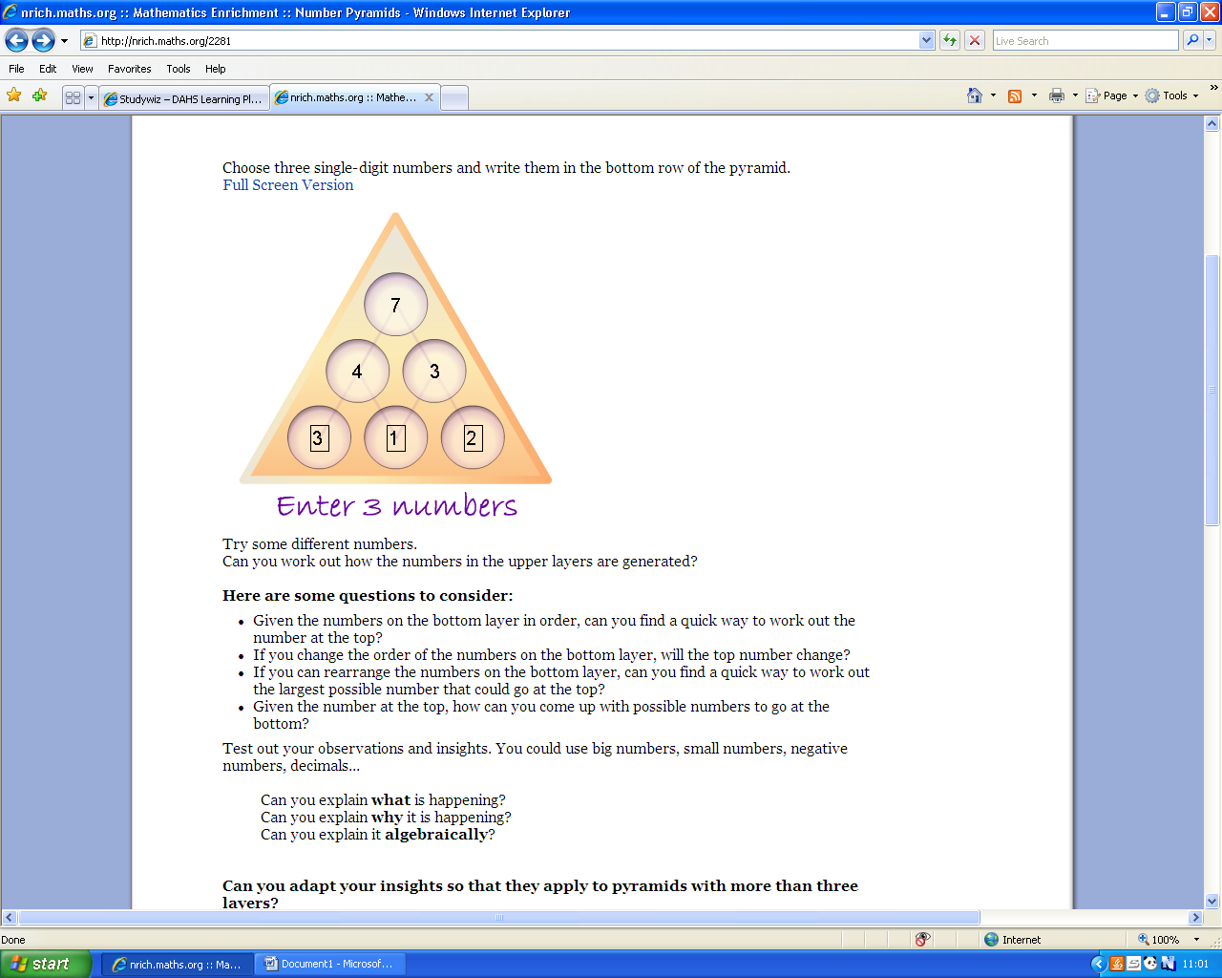
The top number will be a+b+b+c if a=1 b=2 and 3=c

c
b

a
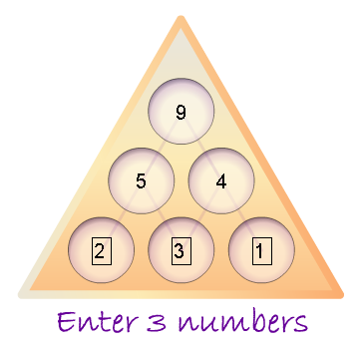
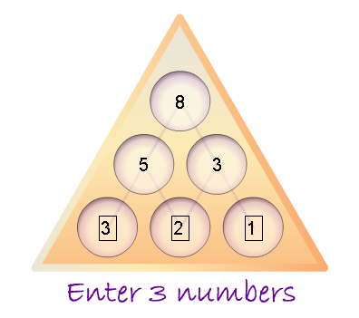
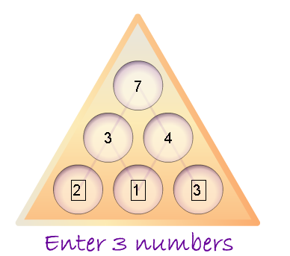
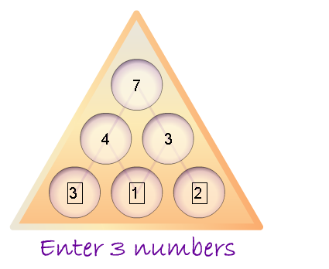
The biggest possible number you could make is the original 3 bottom numbers plus 3.
If you change the order of the bottom numbers then the top number will change.

The equation for the number at the top is a+b+b+c.

There will be more than 1 set of possible numbers.

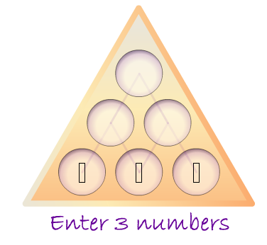
This time, a=11, b=1 and c=2.
15
3
12
2
1
15
11
3
12
15

