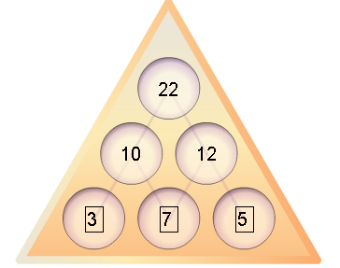
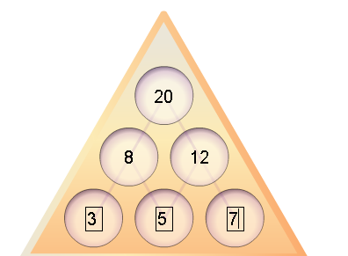
I have found that if you add the first two numbers ,you will get the right hand side number and if you add the middle number and the last number,yuo will get the left side of the triangle and then you add these two numbers together to get the top number

I have also found that if you change the order but the middle number reamins the same e.g 257 becomes 753 the answer stays t he sma ebut if you changwe the order completely it will be different e.g]
7,5,3 becomes,3,7,5 the answer becomes differnet..like this

Thid is because the 7 is being added twice but befor,with the smae three nu,bers,the five was being added twice,it would still be different if the tthree was in the middle too.

The largest possible number that can be made is 36 as you have to add the three largest sungole digit numbers which int hsi case is 9.

