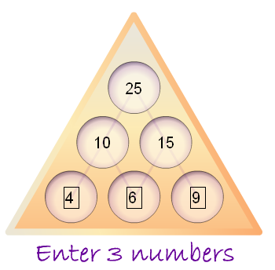
The upper layers are generated by adding the two numbers on the left and right to the middle number , then adding the two numbers after that to generate the last number at the top. In this case it would be, 4+6 to make 10 then 9+6 = 15 then add 15 and 10 = 25. It is very similar format to the tree diagram method,
Questions to consider
- A quick way to work out the number at the top of the pyramid, would be to add 4 + 6 + 10 and 6+9 = 15 then add them straight away.
- It depends on how they are rearranged because if the 6 is still in the middle and the 4 and 9 switch round then the number at the top would stay the same. However if the 6 rearranged then the number at the top would change.
- If you rearranged the numbers on the bottom layer to find the largest possible number you would have to put the largest number on the bottom row in the middle for example you would but the 9 in the middle.
- You could find the rest of the pyramid just by using the top number of the pyramid by doing reverse calculations , saying the number at the top was 25 as shown above, you would figure out which two numbers would add together to make 25 for example 10 and 15 then figure out which numbers add to make 10 and 15.

Explaining what happens on the number pyramid when you use other numbers like big ones small ones, negative ones, and decimals the numbers on each row would be very different. For example if we used decimals the number at the top would most likely become a decimal itself and using negative numbers would make the number at the top become negative and so on...

