- Yes, we can work out the top number without finding out the middle number.
Solution: Let’s say the bottom left number is ‘a’. Since the numbers are consecutive, the second left number would be ‘a+1’. The third would be ‘a+2’ and the fourth ‘a+3’.

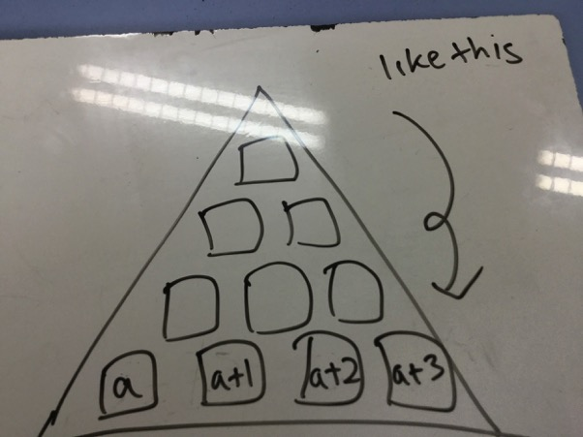

The pyramid’s bottom’s number adds up to the the middle numbers, so:
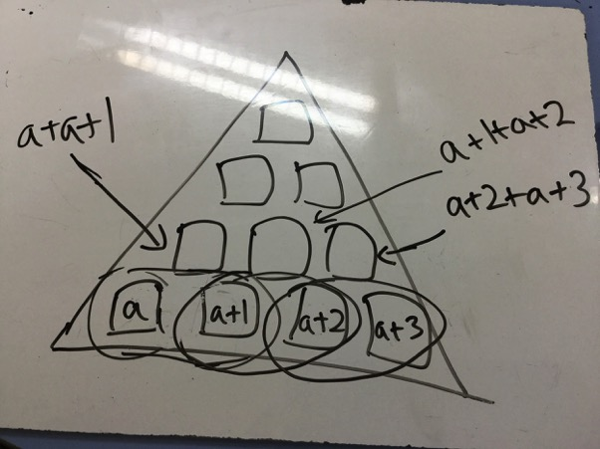
Simplified:
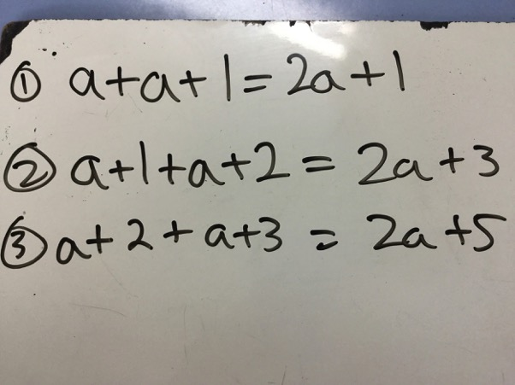

So the next layer would be:
2a + 1 + 2a + 3 and 2a + 3 + 2a + 5 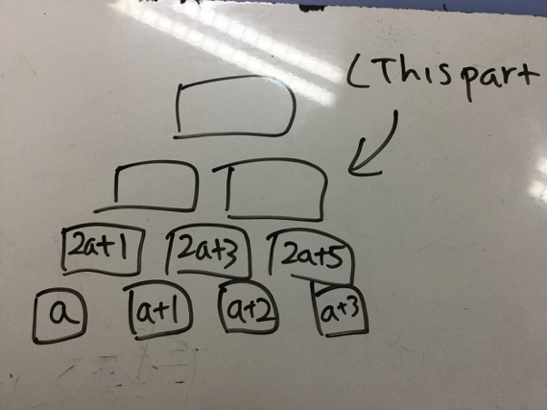
Simplified:
2a + 1 + 2a + 3 = 4a + 4
2a + 3 + 2a + 5 = 4a + 8

The last layer would be:
4a + 4 + 4a + 8 = 8a + 12
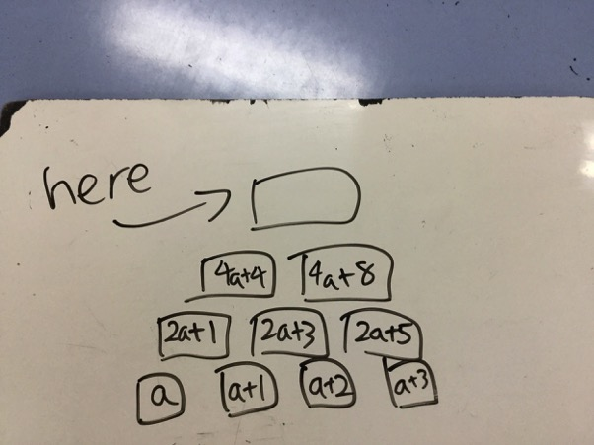

Simplified:
4a + 4 + 4a + 8 = 8a + 12

Formula:
(Total of bottom 4 numbers) x 2 = top number of the pyramid

This way of finding the top layer without the middle layer works.
Example to prove the way works:
