Number Pyramids
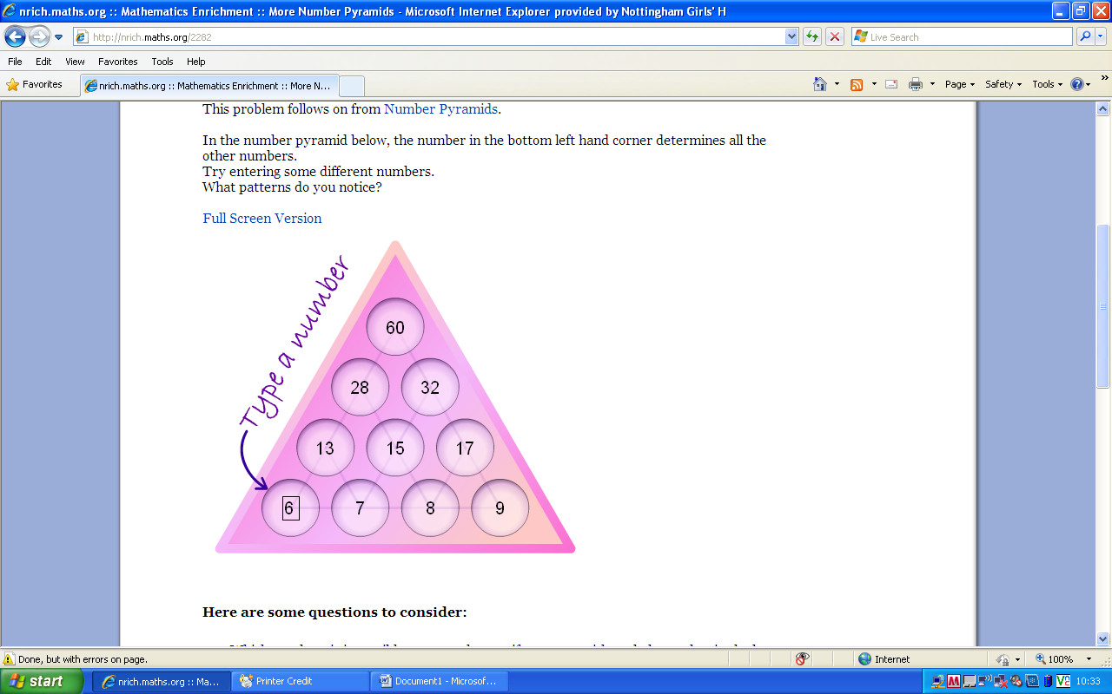
8n+12
4n+4 4n+8
2n+1 2n+3 2n+5
n n+1 n+2 n+3

8n+12 = 4(2n+3)
So the number at the top of the pyramid is always a multiple of 4. This means any number that isn’t a multiple of 4 will never appear at the top.

e.g. When the number at the bottom left is 1
4(2n+3)
= 4(2x1)+3
= 4x(2+3)
= 4x5 =20

