Nrich Puzzle Ayaan Jafri 11/10/2020

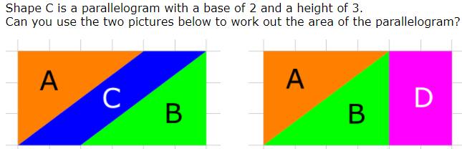
The area of the parallelogram is 6cm² because in the second picture, D is equal to C.
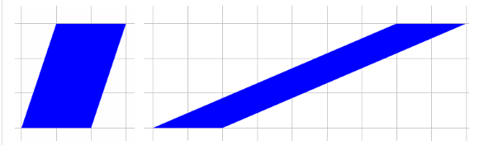
The area of the parallelogram which has a base of 2 and a height of 3 is 6cm² judging by the diagram.

Using the GeoGebra applet to explore other parallelograms with a base of 2 and a height of 3, I have noticed that all of the parallelograms have an area of 6cm².
General Rule
The general rule for working out the area of a parallelogram if you know its base and height is to just simply multiply the base with the height which will provide you with the answer. This rule works because as you can see in this parallelogram: I will assume that the height is 4cm and the base is 2 cm. It will work because if we split the parallelogram at the side like this , you can move that part to the other side making a rectangle.
This is why this rule works.

