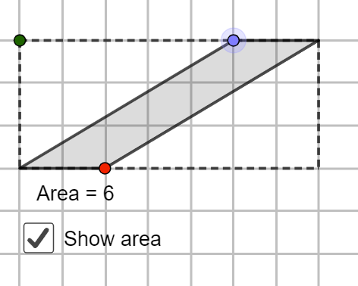
As you can see, this is the original shape of the parallelogram.

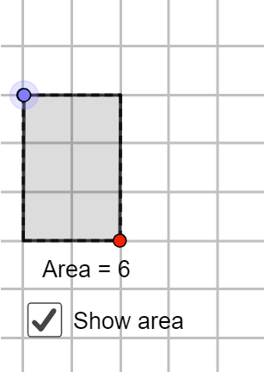
When we transform the parallelogram into a triangle, it still has the same amount of area.

Now I will tell you why this happens.
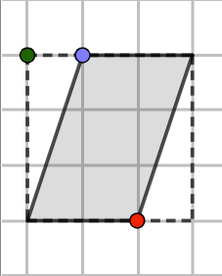
e.g. If you have a parallelogram with this shape, all you must do is identify the shapes within the parallelogram.

The blue shape is a rectangle, and the green shapes are the triangles.


If you notice, if you put the 2 triangles together, you get another rectangle.

Finally, if you add the 2 rectangles together, you get the area of a parallelogram.

This is the rule for parallelograms

