Shear Magic
Working out the area of C
Counting the number of squares around both diagrams, we can see that both the rectangles have the same area of$6×3$. Since both the shapes have Triangles A and B in common, the area of C and D must be equal. D is a rectangle and the area of a rectangle is base times length. Counting the squares around D, we get that the area is $2×3$= $6$. So the area of the parallelogram C is also 6.
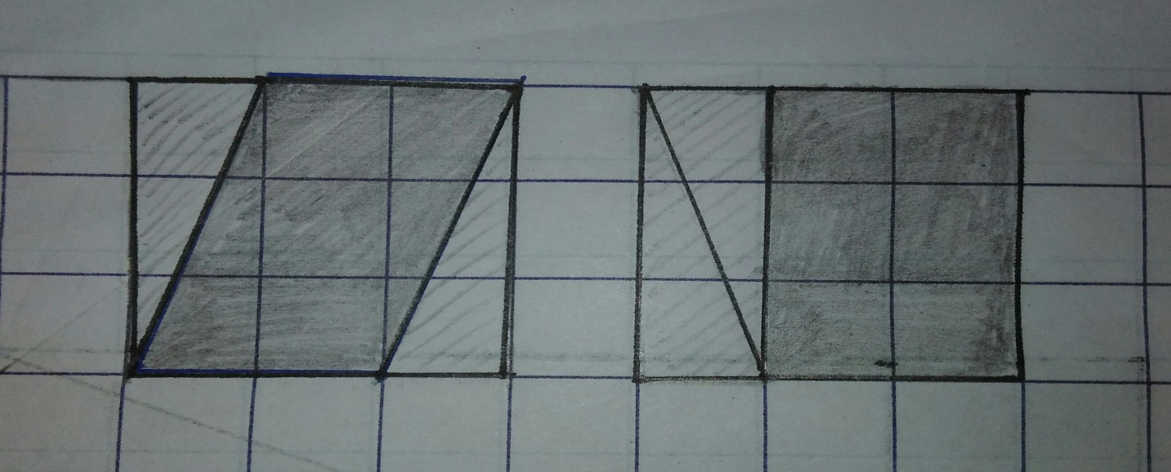
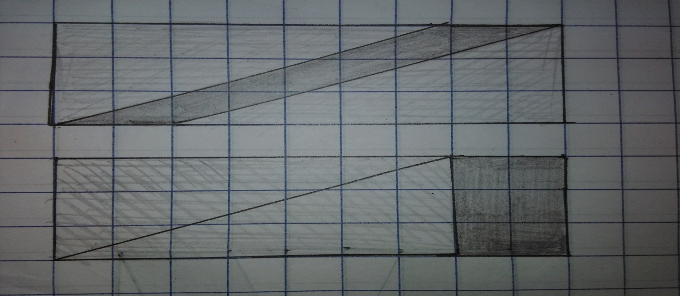

After I worked out the area of the parallelograms above, I figured that a rectangle was just a unique parallelogram i.e., a parallelogram could be moulded into a rectangle and the area would not change. The rectangle would then have a base that equals the parallelogram’s base and a length which equals the height of the parallelogram. The area of the parallelogram would therefore be the area of the rectangle which is nothing but the base of the parallelogram times its height.
Using the GeoGebra applet, I figured that as long as the base and height of the parallelogram were kept constant, the area would not change.
Triangles
Using the GeoGebra applet, I noticed that the area of a triangle was half the area of a parallelogram which can be formed by diagonally reflecting the triangle. The parallelogram would then have the same height and base as the triangle. Since the area of a parallelogram is base times height, I could say that the area of a triangle would be half its base times height.

