Nrich Solution for Tilted Square

Myself, Shubhangee, had worked in Ganit Kreeda, Vicharvatika, India with 17 kids, Tejas, Ruhi, Valerie, Mithravinda, Rivaan, Kabir, Akshobhyan, Nithya, Deethya, Uday, Udit, Tarikha, Kashvi, Swathi, Devasena, Arnav, Samarth; of 4th to 6th grades on Tilted Squares task. It was very value adding and brain storming session.
I enjoyed the task as there is lot of exploration and learning involved.

- Can you find a quick and easy method to work out the areas of tilted squares?

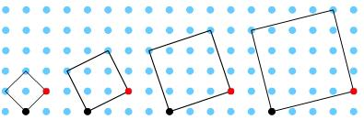

- Area of first square was discussed in the session. Kids found out 3 different ways to calculate the area of first tilted square as:
- Kids divided it into 4 equal triangles and 2 triangles will make one square.
So, the area of first tilted square is 2 sq unit.
- Area of each triangle is ½ sq ut.
So, total area of 4 triangles together = 4 x 1/2= 2 sq ut.
- They calculated area of outer square and subtracted extra area from it as 4 – 2 = 2 sq unit

For the second tilted square,
- kids divided it into 4 equal triangles and 1 square.
Now 2 triangles will make one rectangle of area 2 sq unit.
So, the area of second tilted square is 2 +2 + 1= 5 sq unit.

- area of bigger sq = 3 x 3 = 9 sq ut.
Area of each triangle (A/B/C/D) = 1.
So, area of 4 triangles = 4 sq ut.
[Or A&B together make a rectangle of area 2 sq ut .
So, area (A+B) = 2 sq ut and Area(C+D) = 2 sq ut]
Area of tilted square = 9 - 4 = 5 sq ut

Kids also found out area of all other squares using similar approach and tubulised the results as:

Sr No. | Original Square | Area of Original Square | Area of Tilted Square | Observation | Pattern
1 | 1x1 | 1^2=1 sq ut | 1/2x4=2 sq ut | 1+1=2
2 | 2x2 | 2^2=4 sq ut | (1x4)+1=5 sq ut | 4+1=5
3 | 3x3 | 3^2=9 sq ut | (3/2 x 4)+4=10 sq ut | 9+1=10
4 | 4x4 | 4^2=16 sq ut | (2x4)+9=17 sq ut | 16+1=  17
5 | 5x5 | 5^2=25 sq ut | (5/2 x 4) +16=26 sq ut | 25+1=  26

- Pattern shown in the rightmost column was spotted by Akshobhyan in his homework.
- Tarikha and Akshobhyan observed that:
Area of tilted square = # of dots inside the square + 1.

Akshobhyan’s work:
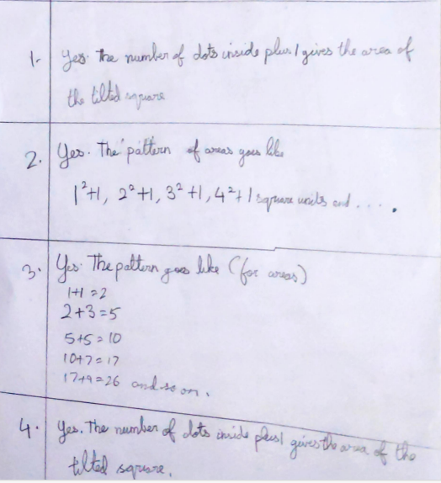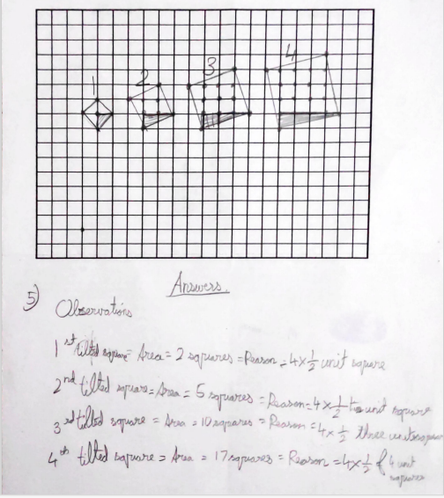

- Collaboratively, kids tabulated all the findings for squares with different tilts as:

Figure No. | Area of Sq with no tilt | Area of Sq with tilt=1 | Area of Sq with tilt=2 | Area of Sq with tilt=3 | Area of Sq with tilt =4 | Area of Sq with tilt=t
1 | 1x1=1^2=1 | 1+1=2 | 1+4=5 | 1+9=10 | 1+16=17 | 1+t^2
2 | 2x2=2^2=4 | 4+1=5 | 4+4=8 | 4+9=13 | 4+16=20 | 4+t^2
3 | 3x3=3^2=9 | 9+1=10 | 9+4=13 | 9+9=18 | 9+16=25 | 9+t^2
4 | 4x4=4^2=16 | 16+1=17 | 16+4=20 | 16+9=25 | 16+16=32 | 16+t^2
5 | 5x5=5^2=25 | 25+1=26 | 25+4=29 | 25+9=34 | 25+16=41 | 25+t^2
n | nxn=n^2 | n^2+1 | n^2+4 | n^2+9 | n^2+16 | n^2+t^2

- The discussion was taken ahead with the following results:
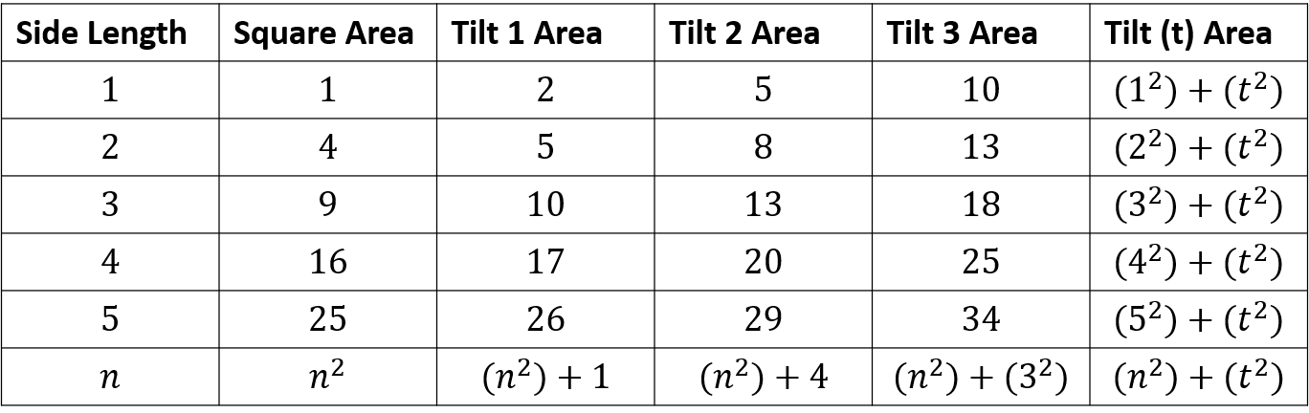
Rule: Tilt area = square area + (tilt)^2, or n^2+t^2 where n= square length and t= tilt of square

- Kids added no of complete squares and area of two identical rectangles.

- They experimented with interactivity and noticed that
width of the rectangle = tilt(t) and
length of the rectangle = original square’s length (n).
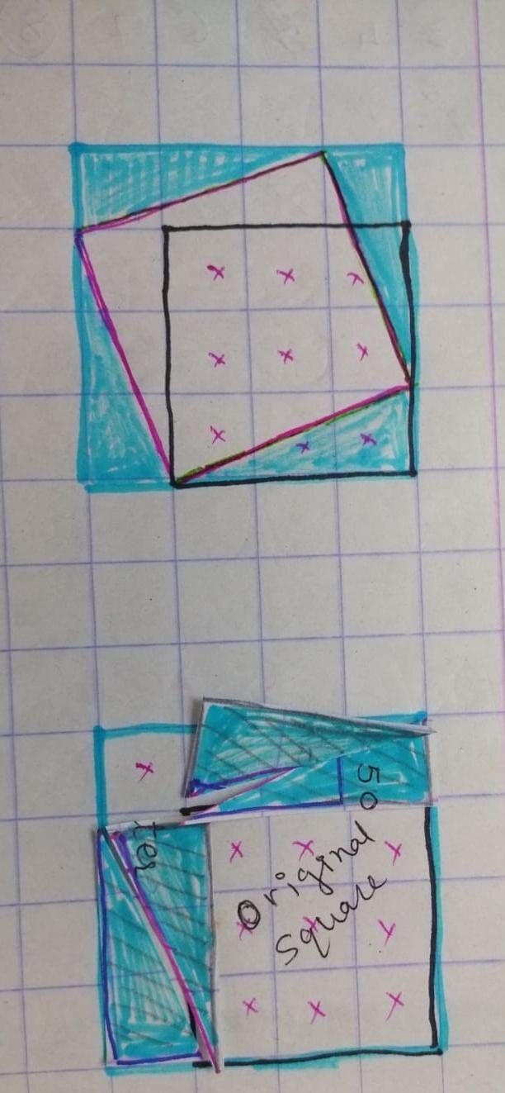

From fig 1;
Area of tilted square = Area of white part

We then cut blue 4 triangles and rearrange them to form 2 rectangles as shown in fig 2;
So, area (tilted square) = area of white part = n^2 + t^2

Also, Area of outer square [with side (n+t)] = (n+t) ^2 -----(1)
It is clear from fig 2;
Area of outer square = n^2 + t^2 + 2nt -----(2)
From (1) & (2)
(n+t) ^2 = n^2 + t^2 + 2nt

NOTE: We proved and explained pictorially the first identity (a+b) ^2 = a^2 + b^2 + 2ab

Also, we proved Pythagoras theorem from fig 1 as
Area of tilted square = n^2 + t^2
OR side of tilted square= sqt (n^2 + t^2)
That means (hypotenuse of right angle triangle)^2 = sum of squares of other 2 sides.

