PAINTED CUBE INVESTIGATION
By Longford
What Is It?
The Painted Cube Investigation is a scenario where you have a cube, much like a Rubix Cube (3x3x3), and have to work through questions such as; how many faces are Red/ Yellow? How many cubes have more than one yellow face? Etc.
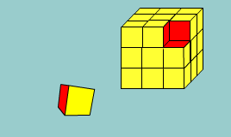
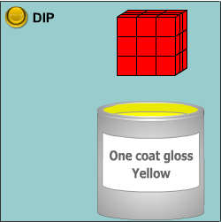

What to do
There is a large cube made up from 27 small red cubes.
Imagine dipping the large cube into a pot of yellow paint so the whole outer surface is covered, and then breaking the cube up into its small cubes.

How many of the small cubes will have yellow paint on their faces?
Will they all look the same?

Record your findings ready to present them to the rest of the class.

TEAM ROLES

Facilitator
Make sure that the task is clear to everyone, that the group is working together towards the agreed goals, and that everyone is participating and has their ideas heard.
Recorder /Reporter
Make sure important ideas and results are recorded. Record strategies and methods as well as solutions, and be ready to share the group’s mathematical journey. Make sure that the team is ready to report at the end.
Resource manager
Make sure everyone has a useful task to work on, and that they have the tools and information they need to complete the task. You are the only one who can call the teacher over to ask questions but you must make sure that all questions are agreed by the team.
Understanding coordinator
Make sure that calculations are checked and mathematical reasoning is justified. Make sure the group is linking ideas.

THE QUESTIONS YOU HAVE TO ASK YOURSELF
HOW WILL WE REFLECT ON WHAT WE HAVE DONE?
HOW WILL WE SOLVE THE PROBLEM?
WHERE DO WE START?
WHAT WILL WE DO WHEN WE HAVE AN ANWER?
WHAT DO WE HAVE TO FIND OUT?

Size of cube | 3 painted faces | 2 painted faces | 1 painted face | 0 painted faces | Total number of cubes with painted faces
2 x 2 x 2 | 8 | 0 | 0 | 0 | 8
3 x 3 x 3 | 8 | 12 | 6 | 0 | 26
4 x 4 x 4 | 8 | 24 | 6 | 0 | 38
5 x 5 x 5 | 8 | 36 | 6 | 0 | 50
Recording what you find

Can you see the pattern? Explain for a 6x6x6 cube.
Extensions.
Work out a formula or a rule for the above results table.
Do another table, but with the faces that have not been painted. Work out a rule.

Evaluation.
Did your team work well?
Did you finish in the time period?
Reflecting on and making use of what has been said
Being concise - communicating thinking
Explaining by telling how and why
Most importantly... Did you make good use of your TEAM ROLES?

