AREA L

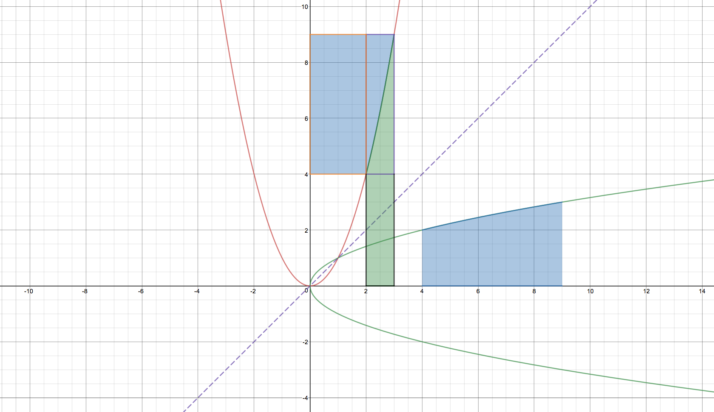
The red function is $y=f(x)$, the green function is its inverse $y=f^{-1}(x)$ which is the reflection of $y=f(x)$ in the line $y=x$. The blue area under the green function represents $\int_{f(a)}^{f(b)}{f^{-1}\left(x\right) dx}$. The blue area between the red function and the $y$ axis represents $\int_{f(a)}^{f(b)}{f^{-1}\left(x\right) dx}$ but reflected in the line $y=x$. The green area represents $\int_{a}^{b}{f(x)}dx$. $\int_{a}^{b}{f(x)}dx+\int_{f(a)}^{f(b)}{f^{-1}(x)}dx$ is represented by the sum of the green area and one of the blue areas. We can prove the result if we use the blue area between the red line and the $y$ axis.

As we can see, the area represented by $\int_{a}^{b}{f(x)}dx+\int_{f(a)}^{f(b)}{f^{-1}(x)}dx$ is made up of three rectangles, and the total area of the shape is

$$a\left(f\left(b\right)-f\left(a\right)\right)+\left(b-a\right)\left(f\left(b\right)-f\left(a\right)\right)+f(a)(b-a)$$

Which simplifies to $bf\left(b\right)-af(a)$.

A nice example of using this property is to evaluate the integral $\int_{0}^{1}{\ln{x}dx}$

$$\int_{0}^{1}{\ln{x}dx}=-\int_{-∞}^{0}{e^{x}}dx+0\left(e^{0}\right)-∞\left(e^{-∞}\right)$$

Which simplifies to

$\int_{0}^{1}{\ln{x}dx}=\int_{0}^{-∞}{e^{x}}dx$

Looking at the right hand side, this is $e^{-∞}-e^{0}=-1$. Therefore $\int_{0}^{1}{\ln{x}dx}=-1$

