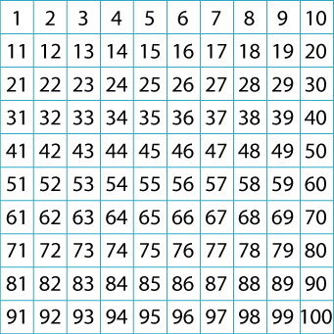
We figured out the corners, which was easy, because all you had to do was to swap the opposite corners. So the corners are 1 - 10 and 100 – 91 is. We also found out that if the 10 is where the 1 is, that means that the 20 has to be on the back of the 11 and so on. We figured out that 91 is on the back of 100, 58 is on the back of 53, 23 is on the back of 28 and the last one is 29 is on the back of 22. How we figured out all these is that we knew 91 was on the back of 100 and for the others we only had to swap numbers across on the same row.

