See the picture below. The sun creates shadows of a cane and a tree so we have two similar triangles. If we measure the shadows of the cane and the tree at the same time, the ratio of corresponding sides from the similar triangles is equal.
So, AE: AC= DE: BC, or $\frac{length of tree^{'}s shadow}{length of cane^{'}s shadow}=\frac{height of tree}{height of cane}$.
What do I know?
I know that the height of the cane (BC) is 1m. The length of the cane’s shadow (AC) can be measured. For example, we assume it could be 2m. Suppose the length of tree’s shadow (AE) is 100m.
How do I work out the height of the tree (DE)?
Substitute the known values into the equation above.
$$\frac{100}{2}=\frac{DE}{1}$$
we need to divide 2 by 2 to get one then to keep the equivalent fractions divide 100 by 2 which is 50. DE=50m.
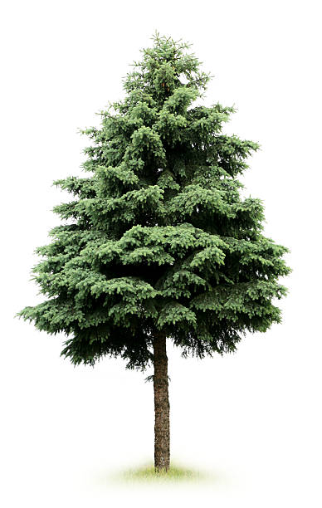

D


B

1m

A
100m
2m

E
C

