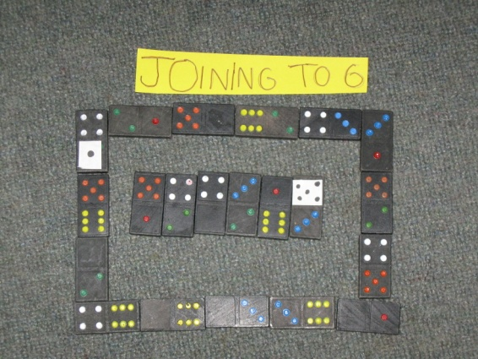
Joining to 6!
This was really easy, we all had lots of fun doing this we all liked it.

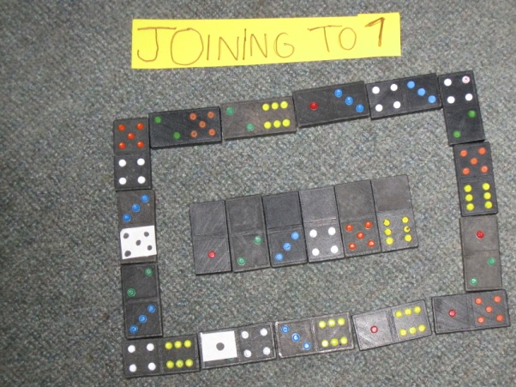
Joining to 7!
This was a bit tricky but we all worked as a team and got it done. We also worked out that the blank ones had to be left out.
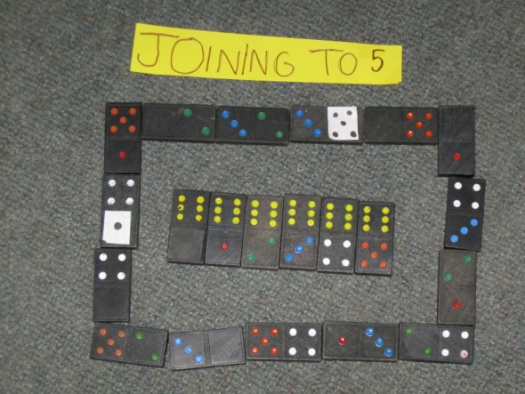
Joining to 5!
This one was easy because we knew that we had to get the sixes out of the road so it can work.
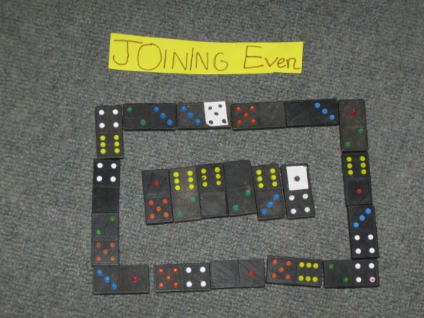
Joining even!
This was easy because we just had to put two even numbers or two odd numbers together and it will make an even number.

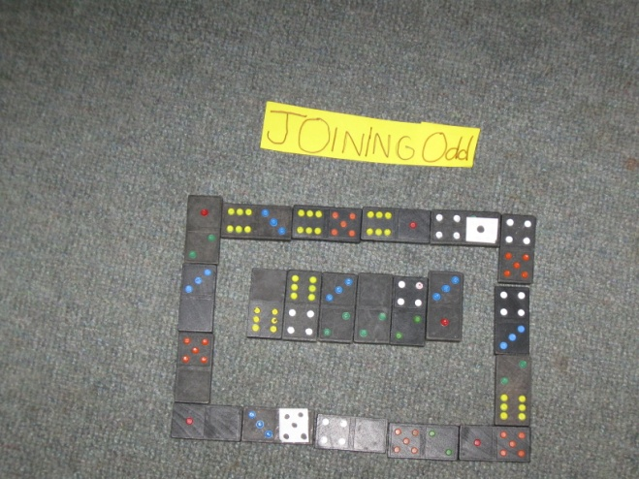
Joining odd!
This was easy because we got help off the even one a bit. Then we just kept on working really hard as a team and got it done.

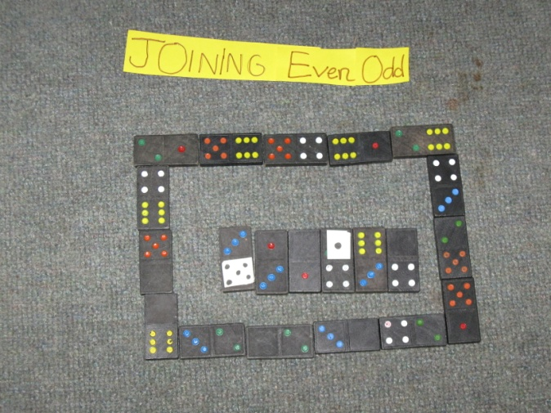
Joining even then odd!
We did this one for a bit of fun and we had lots of fun. We had to work out what will fit together and what won’t.

