Teresa – on how to start
The first thing I do is put 3 triangles in a row, to try and do the technique where you win automatically because you have 2 possible squares where you only need one more to win.

Lautaro – on how to start
I will start in the middle because it gives more opportunities than going to the side or whatever, normally,
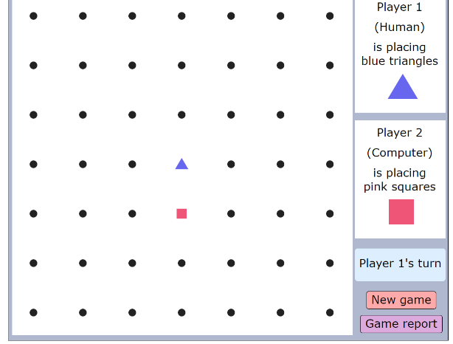
Sophia – on how to start
I would place my second move on the second dot above my first triangle. This is because I can lay out a trap. (triangle diagonal) to easily win the game. I chose to place the diagonal-positioned triangle after so there will be less give-aways of the plan.

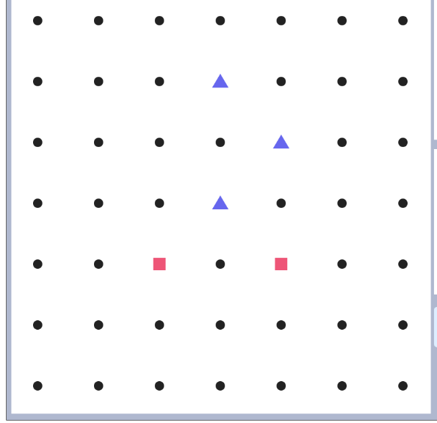
Lautaro – on why the blue triangles have already won in this diagram
Here, the triangles are going to make a square. Squares have no choice except to block-it. After its blocked triangle, put one triangle in the middle of the patented square. It’s a checkmate because eider squares block one or the other, triangles is going to put a triangle and form a square.

Vince – on why blue triangles have already won in this diagram
The blue triangles have already won at this point because the red squares see that the triangles are almost done with their square so red tries to block blue. Unfortunately for red it was too late because there are two little tricks that blue can do.

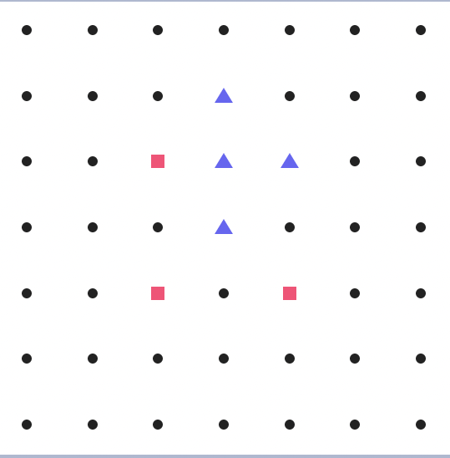
The first and most popular trick is to put a triangle in the middle of the three other triangles. This creates something where blue has two options to win. And when red blocks one of them, blue can use the other one to win.

Trick 1

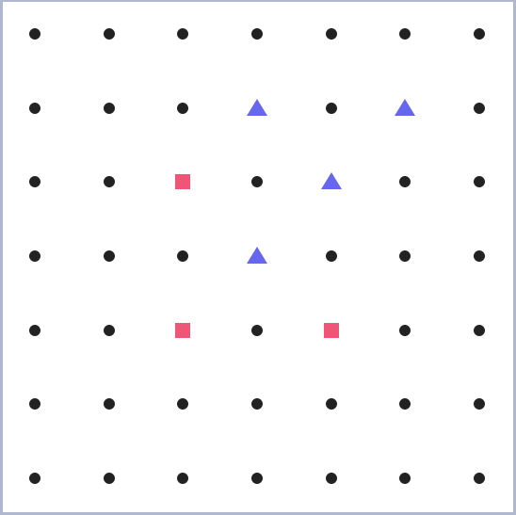
The second but my personal favourite trick is to add a triangle in the close top right corner to make the same thing as before but just in a different format. In this case, the red player will have to pick a way to lose.
Trick 2

Vicente – on why blue triangles have already won in this diagram

Because if you make that shape you are one move away from making a large square but if the opponent blocks you, you can put your triangle in the middle of the three triangles which would lead to two squares which are one triangle away from making a square but if the opponent blocks one of the squares then you have the other one which is one triangle away so if you put your triangle there you win

