Square It - Rishik Kar
Link - https://nrich.maths.org/squareit
Observations and game plans:
- If given a choice a player should try to begin first as it not only increases the success rate by opening many possibilities but does not let the player became obstructed by disruptions. The first player should choose to place their dot on in the centre of their grid as this allows many chances for the player to win.

- Although the minimum point of dots placed on the grid to win is 4, it is very unlikely that the player will be able to win in their first trial. I believe that the next number of minimum dots a player must place on the grid is 5. This grid on the left shows how, and I am blue; the computer is red and the image on the right displays my order of moves. Please keep in mind, that this is only one of the many ways you can make a square.
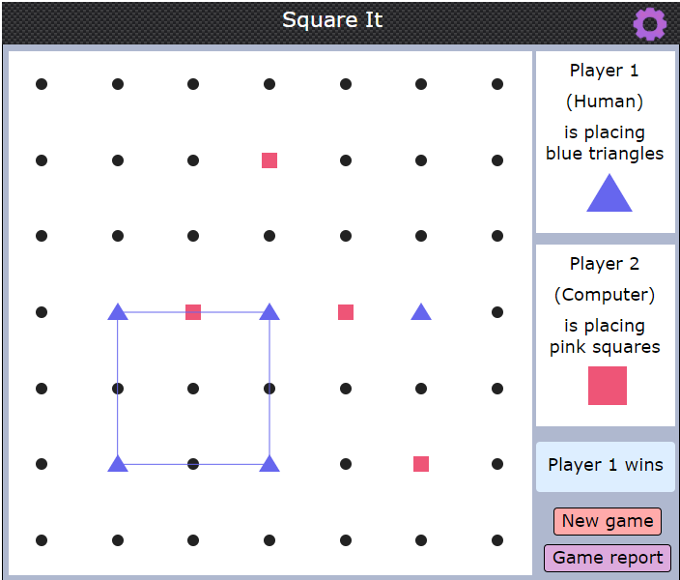
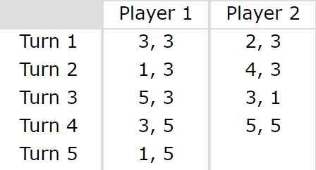

- The player should always try to form two formations: the arrow and parallelogram.
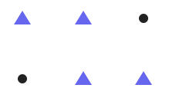
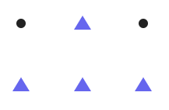
Arrow: Parallelogram:

Although, I have chosen to demonstrate these 2 formations with 3 by 2 grids, they can be formed with any size, by scaling these formations up or rotating or reflecting them in any way on the grid. There are many ways, but these two formations are the best way to secure victory as these create 2 possibilities for you to win and your opponent can only place one counter, thus letting you make a square by completing the other.
- I previously mentioned that not in all cases will a player be able to win with only placing 4 counters. I believe there is one exception and that is by forming tilted squares to deceive your opponent. Players should try to avoid forming simple tilted squares as they are easily noticeable by your opponent but instead form complex tilted squares which are rotated by a certain degree.

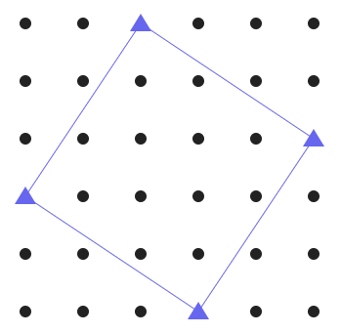
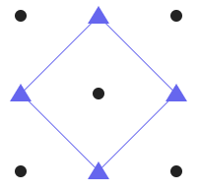
Simple: Complex:
