The answer is 192m², because 17×8=136m² and 8m×7m=56m², then 56m²+136m²=192m²

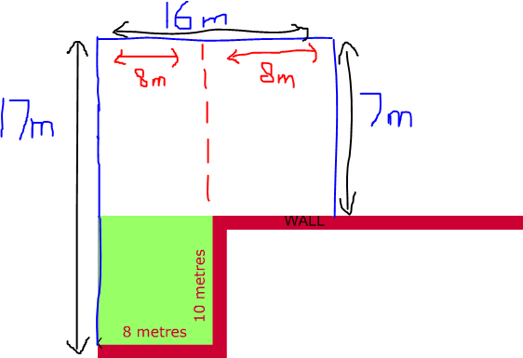
[Type a quote from the document or the summary of an interesting point. You can position the text box anywhere in the document. Use the Drawing Tools tab to change the formatting of the pull quote text box.]

