in a rectangle with sides x and y the perimeter=2x+2y=40m
therefore x+y=20 and x=20-y
and as x increases y linearly decreases
when x=y x=20/2=10
x=10,y=10
Area=xy=10x10=100m²
if x increases by z then y decreases by z.
so if the new sides are (x+z)(y-z)=xy+zx-zy-z²
and x and y=10
then area=100+10z-10z-z²
=100-z²
z² is always positive so -(z²) is always negative
so if it is anything other than x=10, y=10 it will be less.
when there is a wall parallel to side y, the perimeter=y+2x=40
so y=40-2x
and the area=xy=x(40-2x)
for the maximum value of this, we need to find the maximum y value of the graph y= x(40-2x). This can be found at the line of symmetry. This will be halfway in between the values of x for y=0. Y=0 when x=0 or 40-2x=0. If 40-2x=0, 40 =2x so x=20. x=(20+0)/2=10
when x=10, y+2(10)=40
=y+20
Y=20
Area=(2x10x20)=400

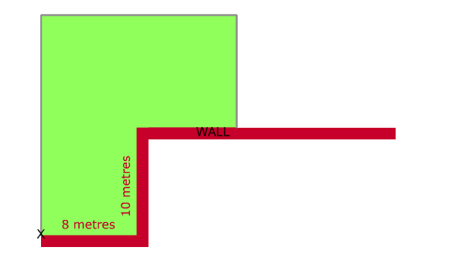
y
x
x
The total perimeter = 10+2x+y=40 2x+y=30
So y=30-2x
In the shape seen above, the surface area is 80+xy
=80+x(30-2x)
for the maximum value of this, we need to find the maximum y value of the graph y= 80+x(30-2x) which will also be the maximum y value of the graph y=x(30-2x). This can be found at the line of symmetry. This will be halfway in between the values of x for y=0. Y=0 when x=0 or x=40-2x=0. If 30-2x=0, 30 =2x so x=15 x=(20+0)/2=10

