Number Differences

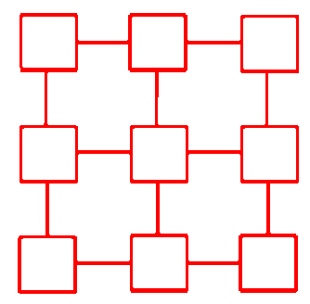
https://nrich.maths.org/2790

Place the numbers from 1-9 in the squares below so that the difference between joined squares is odd. (You must use each number once.)
1
2
3
4
5
6
7
8
9

I have arranged the square at the top left to meet the requirements.
7
2
5
8
1
6
9
3
4
Can you find some other ways to do this? Explain how you do this.

Time to start laying out the information. We know that an even number - an even number = an even number, so we can’t have two even numbers side-by-side. We also know that an odd number - an odd number = an even number, so we can’t have two odd numbers side-by-side. We now know we have to put odds and evens side-by-side to solve this. If we call odd numbers (o) and even numbers (e) then here is the only, generic solution with 5 odds and 4 evens to place.
The only blueprint that fits all solutions is this.
o
e
o
e
o
e
o
o
e

To solve the number of solutions, we should look at the number of placements for the odds and evens separately to find the solution for this. There are 5 odd numbers and 5 seats for them to fill, the number of ways for the first place is 5 as we have 5 numbers. The number of ways to fill the second spot is 4 due to our 4 numbers, and so on. Now we know that there are 120 (5x4x3x2x1) ways to seat the odds.Using this method we get that there are 24 ways to seat the even numbers (4x3x2x1). Multiplying these together we get 2,880 (120 x 24).

This consecutive multiplication is a factorial, this concept is very useful for getting the number of arrangements for anything. If you take maths for A-Levels, then you’ll learn a lot about them.

Can you put the numbers in the squares so that the difference between joined squares is even?Explain your answer.

No, not with consecutive numbers, as you will have to cluster the odds together (as well as the evens.) This results in odd differences when the odds and evens meet.

What general statements can you make about odd and even numbers?

I can make statements saying a) odds and evens are simple to manipulate into your requirments and b) they are the defining force in mathematics as we know it after the base 10 system of writing Hindu-Arabic symbols as numbers. This can be easily seen in this paper.

