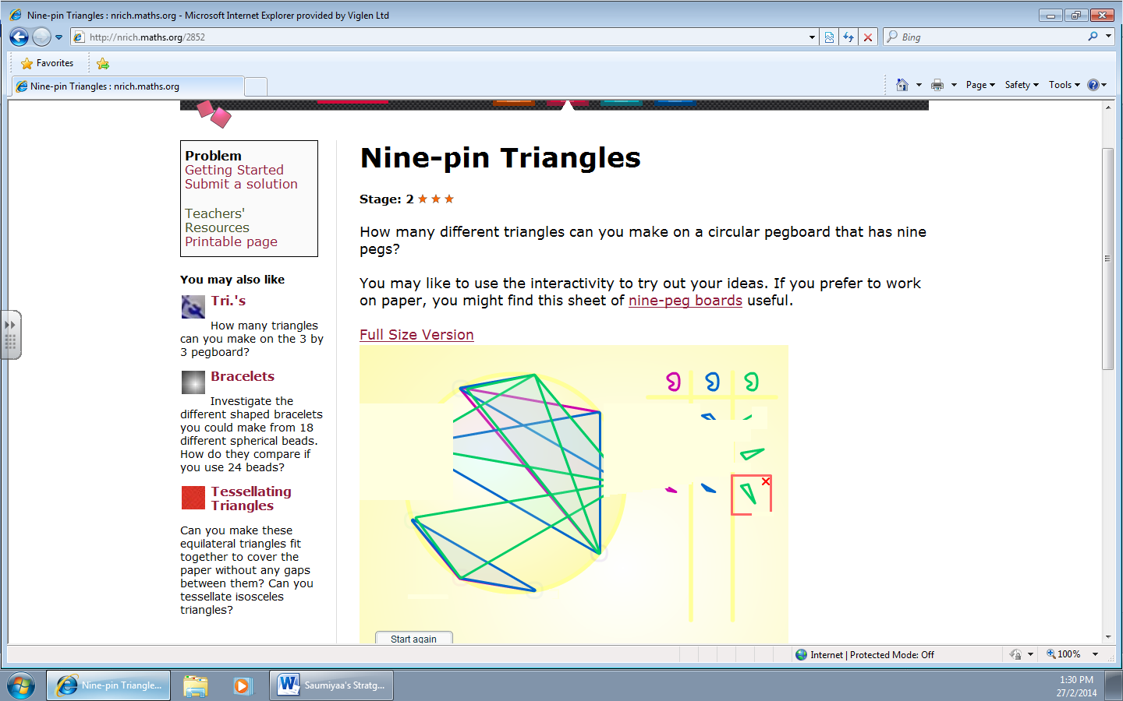
The strategy that I used was I picked a vertex and joined up with two other dots and I did to the other shapes, I did the same producer to get three triangles in the three colours.

