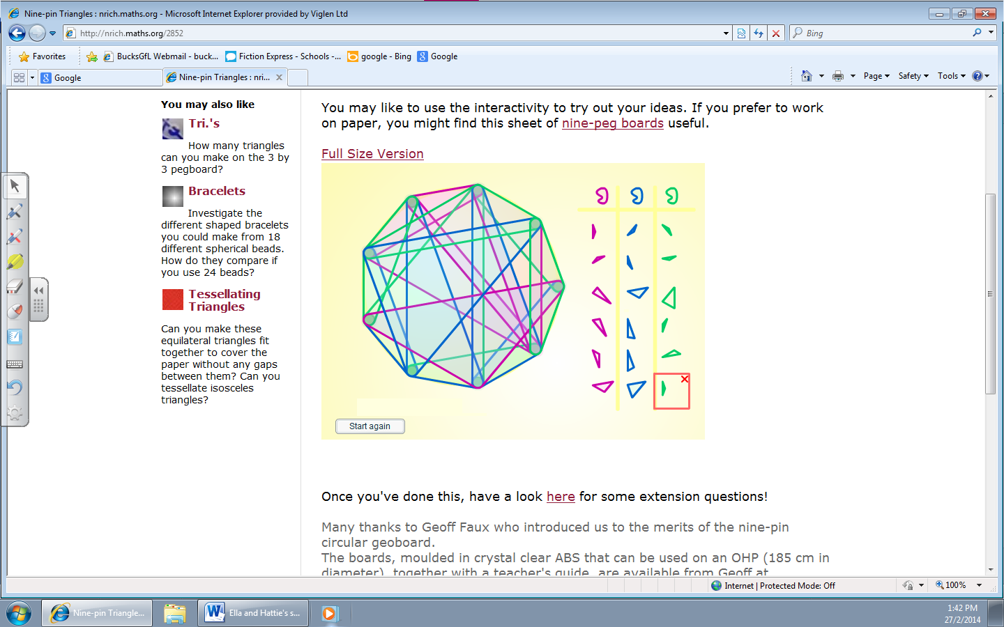
When we were working this out we both thought we should work it out by starting off by making a pattern. We started off by making 6 small triangles around the edges and then we put 2 triangles in the center of the circle. Finally we joined them all together by making different triangles.
By Hattie and Ella

