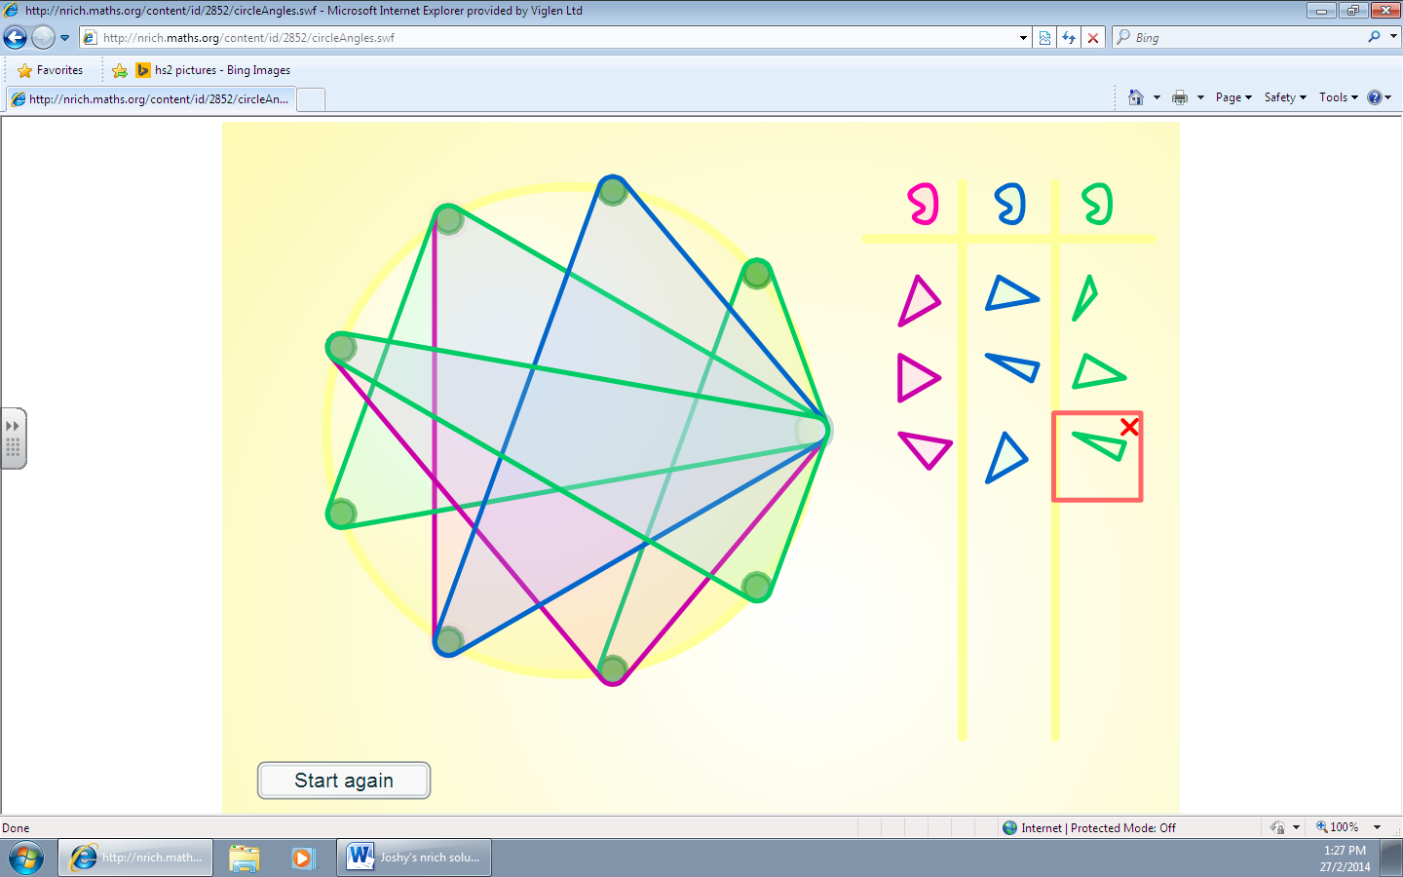

My solution is that, if you attach two of the pins to a random peg and then you always attach the third pin to the peg, it will look like there is glass that is flying towards something and it will smash to pieces and go everywhere.

