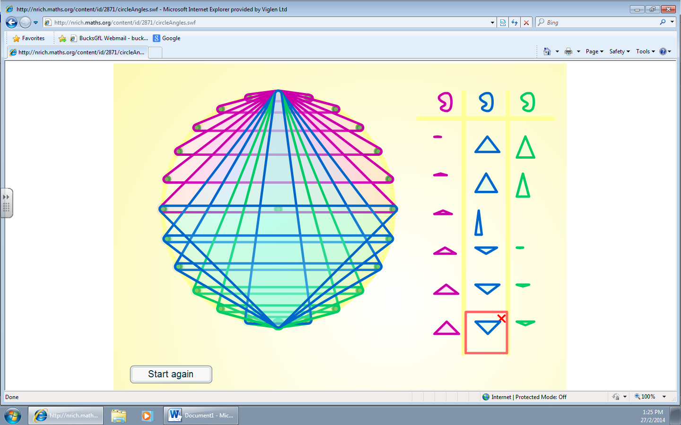
I did all the triangles from one point until they were at the other end and started to do the same back until I ran out of ones I could use.

