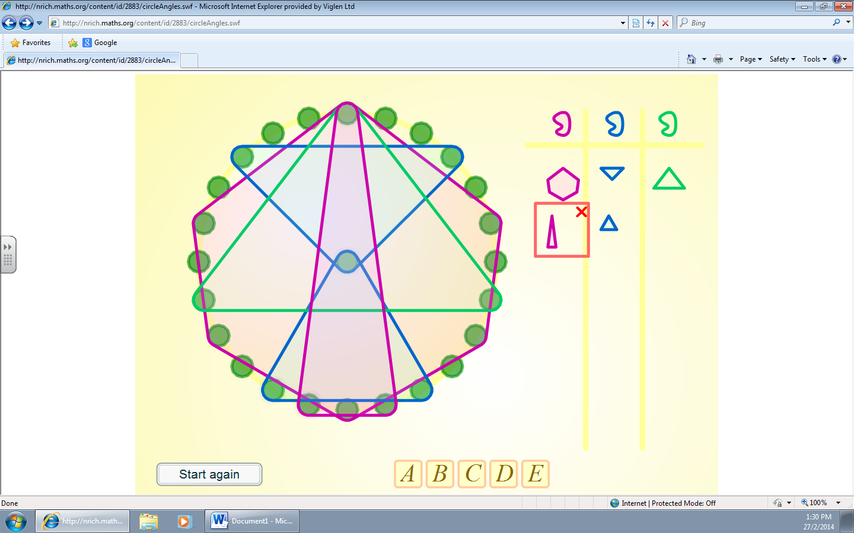
I did lots of different irregular shapes to make this pattern.

