Shapely Pairs solution Nrich

Myself Shubhangee (Facilitator) had worked collaboratively on ‘Shapely Pairs: Triangle cards’ with a group of 18 students of 4th to 6th grade, in online mode, in ‘Ganit Kreeda’, Vicharvatika, India. The names of the students are:
Abheer, Hari, Ashlesha, Asma, Dia, Jamal, Aman, Adhrit, Akhil, Siddhanth, Harshad, Lasya, Kivisha, Ruhaan, Eshaan, Anirved, Saba, Ayaan.
During the session we numbered and labelled them as following:
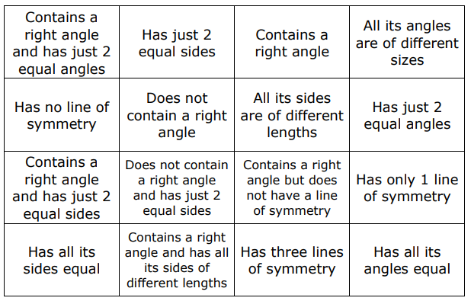

We worked out which type of triangle we will get, looking at each condition separately and mentioned it on individual cards as shown.
Then it was easy to solve third question:
Now suppose that you want to make a pile of cards so that no matter which two you pick; you can always draw a triangle with both those properties. How big could the pile be? Can you give an example?
We grouped them from the type of triangles we got as:
- Isosceles Right-angled Triangle
- Contains a right angle and has just 2 equal angles
- Has just 2 equal sides
- Contains a right angle
- Has just 2 equal angles
- Contains a right angle and has just 2 equal sides
- Has only 1 line of symmetry
- Isosceles but not Right-angled Triangle
- Has just 2 equal sides
- Does not contain a right angle
- Has just 2 equal angles
- Does not contain a right angle and has just 2 equal sides
- Has only 1 line of symmetry
- Right-angled Scalene Triangle:
- All its angles are of different sizes
- Has no line of symmetry
- All its sides are of different lengths
- Contains a right angle and has all its sides of different lengths
- Contains a right angle but does not have a line of symmetry

- Equilateral Triangle:
- Has all its sides equal
- Does not contain a right angle
- Has three lines of symmetry
- Has all its angles equal
Attaching Eshaan’s work here.
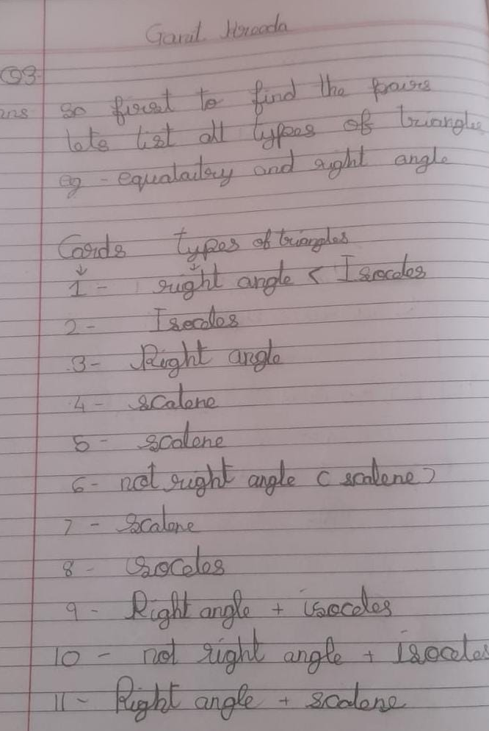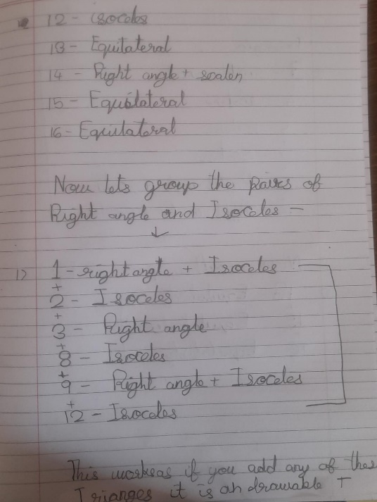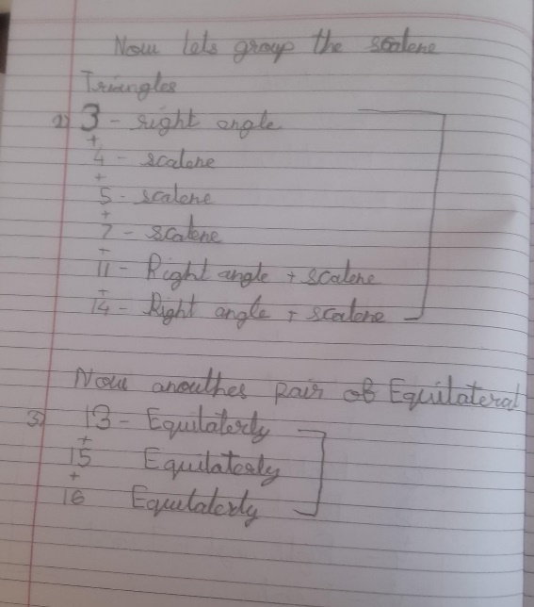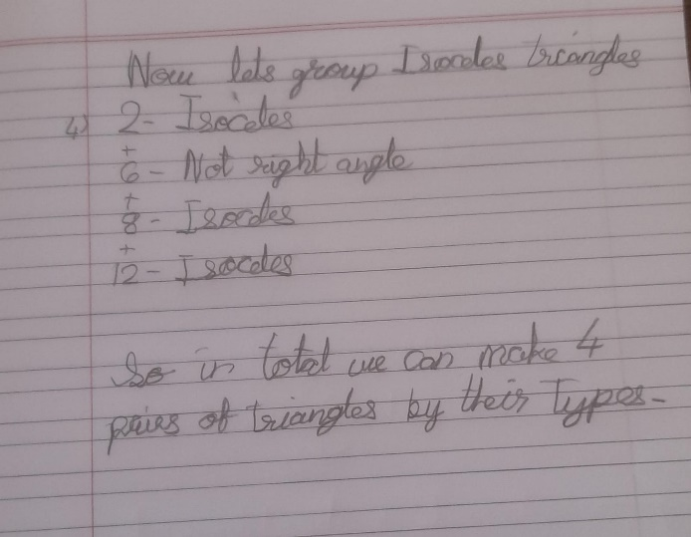
For first question:
Suppose instead of having the cards face down we have them all face up. If it's your turn first, and you want to take a pair of cards, how many possible pairs of cards could choose? Can you list all the possible pairs?
We found different pairs which can go with each other as any two from the groups listed above.
Some other not covered here are:
- Does not contain a right angle + All its angles are of different sizes
- Does not contain a right angle + Has no line of symmetry
- Does not contain a right angle + All its sides are of different lengths

