For first, to briefly know which is the biggest, which is the smallest and which may be the same, We drew one of them exactly the same and cut them piece.
For example,
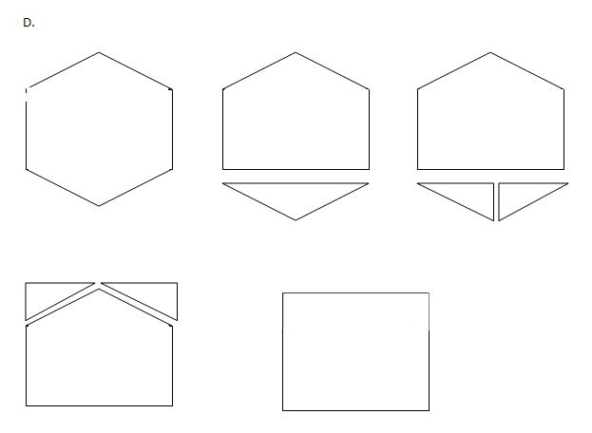
This is the process of D changing into F. Therefore the area of D will equal to F
Then, we calculated all the areas.
For C, for the bottom there is 3 circles and this means that the length of the bottom is 6 unit. Also for the height there are 2 circles so the length is 4 units.
Therefore 4 times 6 is 24.

And as B equals to C, B is also 24.

For E, the bottom rectangle part equals to C so we only need to get the upper part triangle.
For the height there is half circle therefore the height is 1, and the bottom is obviously 6.
Therefore the area of traignle is 3, and we plus this with the bottom part rectangle which equals to 24, then the whole are 27.

For F, as the middle circle got 1 unit higher therefore the height is 5, and the bottom is still 6 therefore 5 times 6 equals to 30.
For A, as shown in the picture below, you can find out the length of one side which is 2√3 + 4
The longer part of the rectangle is obviously 4, and one side of the height of triangle wil be √3 according to Pythagoras’s law.
As the formula for the area of a triangle is (a²√3) / 4, the area of A will be 7√3 + 12.
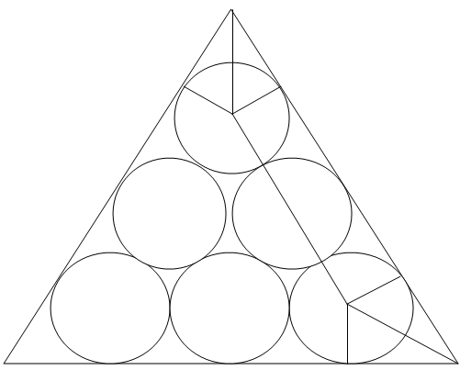
Which is smaller than D,F, or E but bigger than B and C.

Therefore, the answer wil be

D=F > E > A > B=C

