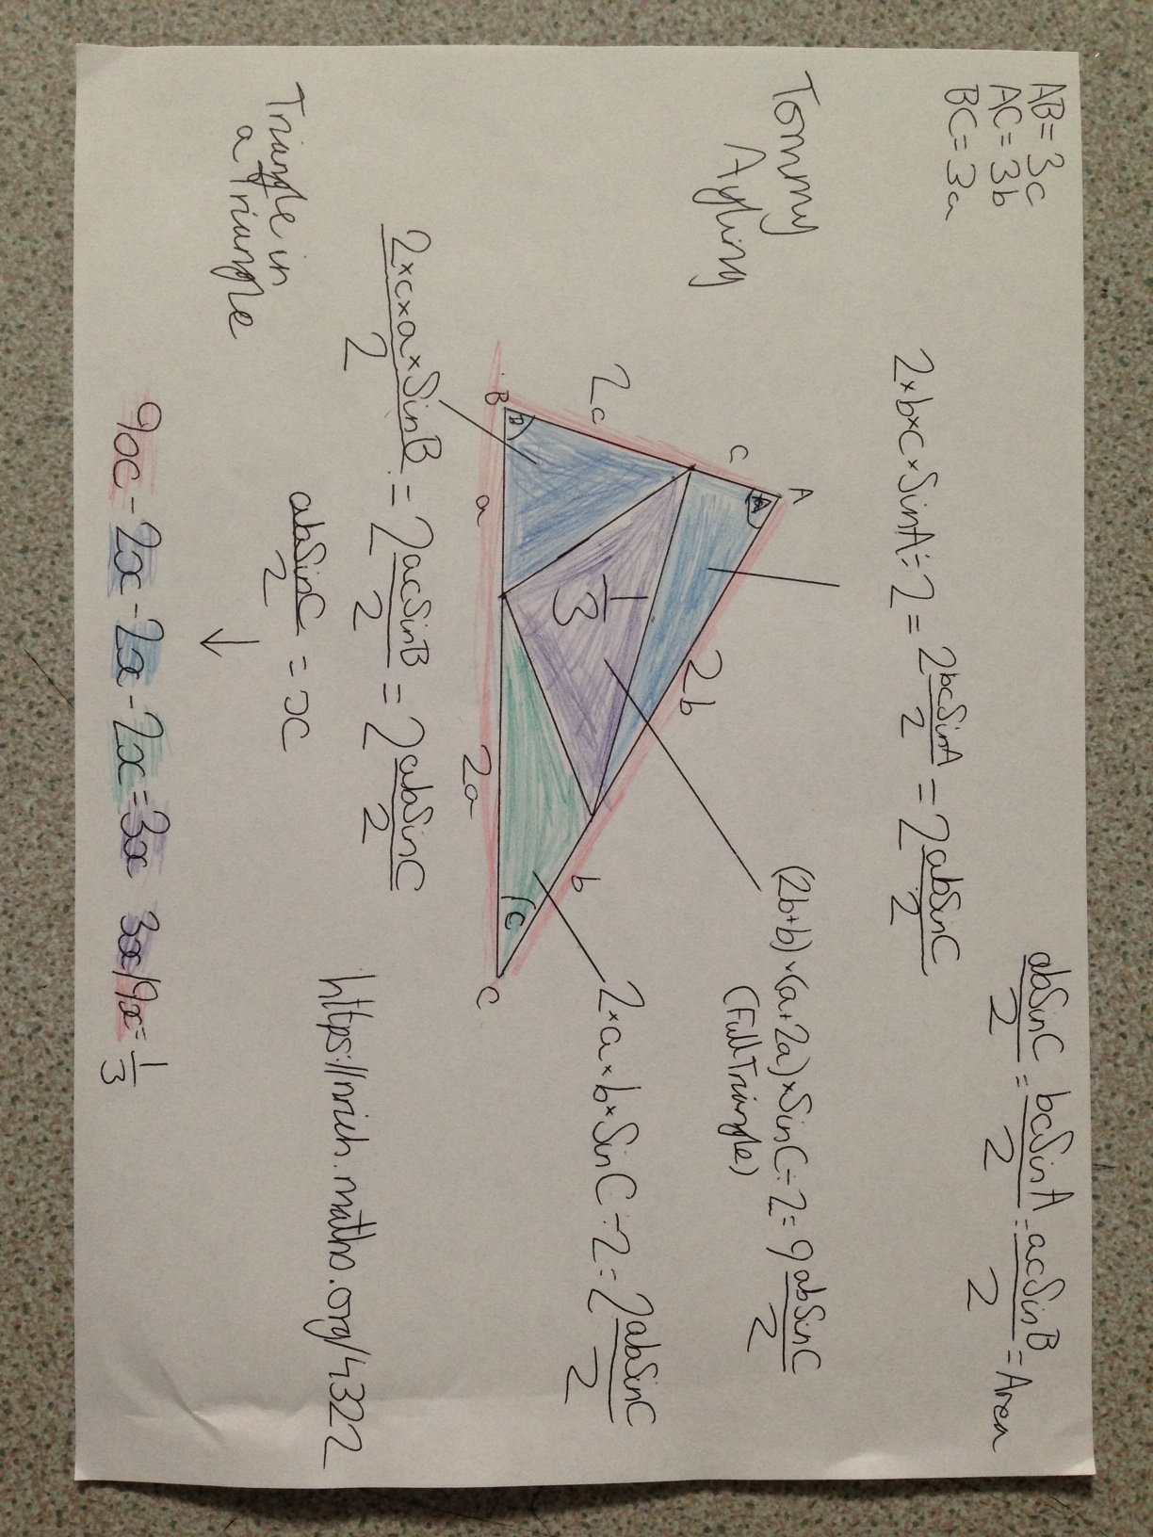
Tommy, Year 8
The Costello School

