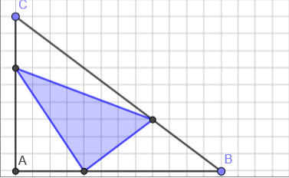
I have used this triangle as it follows a simple Pythagorean triple: 9, 12, and 15 (which simplifies to the 3, 4, and 5 triangle).
AB = 12cm, BC = 15cm, AC = 9cm
AD = 6cm, AE = 4cm
BE = 8cm, BF = 5cm
CD = 3cm, CF = 10cm
FG = 3cm
Using this information we can use Pythagoras to find out the length of EF. EF² = EG² + FG²
EF² = 4² + 3²
EF² = 16 + 9
EF² = 25
EF = 5cm
We can also use Pythagoras to find lengths DE and DF. This is because the Pythagorean triple 5, 12, and 13 can be used.
Now we must find the areas of the triangles.
(9 x 12) / 2 = 54
(5 x 12) / 2 = 30
The fraction of the blue triangle to the large triangle is 30/54 15/27 5/9
G
F
E
D

